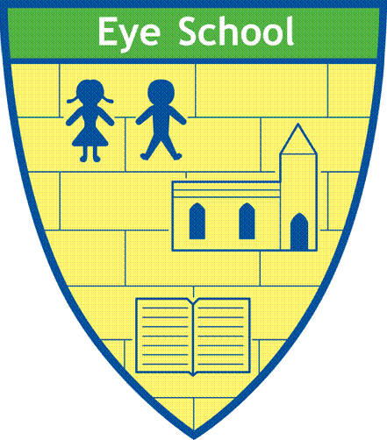

Eye C of E Primary School
Learning and Growing Together
“I came to give life, life in all its fullness.” John 10:10

TEACHING AND LEARNING POLICY
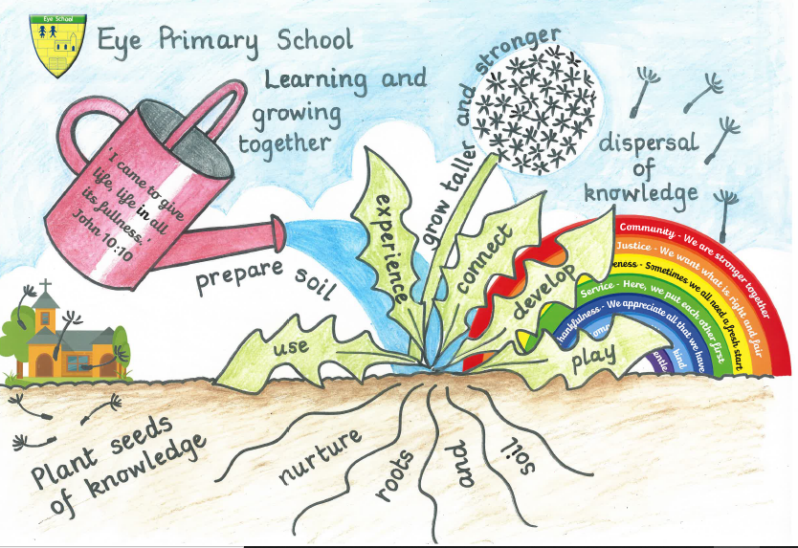

Updated: July 2024
Next Review: July 2025

Eye CE Primary School Teaching and Learning Policy
‘I came to give life, life in all its fullness.’ John 10:10
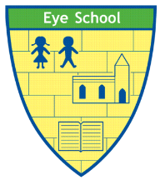

Our Learning and Growing Together cycle for excellence, where learning sticks.
Our vision of excellence and Christian values are at the centre of all that we do at Eye C of E Primary school. They underpin our teaching and learning within which we are constantly ‘Learning and Growing Together’. Our vision is deeply rooted in Jesus’ teachings and specifically in his words from John 10:10, ‘I came to give life- life in all its fullness’. As a Church of England primary school, we are passionate about preparing our children for an undetermined future, by equipping them with life-long, transferable skills and knowledge within a strong Christian context. Every experience and opportunity we provide allows every pupil to live life to the full. ‘Live full lives, full in the fullness of God,’ Ephesians 3:19.

At Eye CE Primary School, we are committed to high quality teaching and learning to raise standards of achievement for all of our children. We know that children only get one chance at their primary education and we want this to be the best it can be by providing every opportunity for children to lead a ‘full life’ and learning and growing together.
The following approach is how we implement our curriculum, which is at the very heart of our school, so that all of our children can access it, enjoy it and flourish as a result of it. We aim to provide a curriculum that is appropriate to the needs and abilities of all our children. We plan our teaching and learning and organise our curriculum in such a way that we motivate every child to reach for the highest level of personal achievement, living full lives: full in the fullness of God.
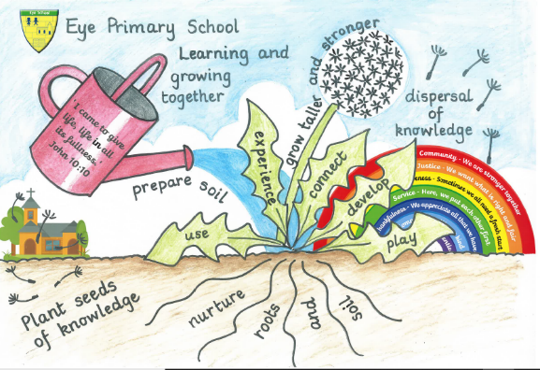

Figure SEQ Figure \* ARABIC 1 The Eye Learning and Growing Together Cycle

Prepare the soil – Plant seeds of knowledge – Nurture the roots and soil – Learning Leaves – Grow taller and stronger – Dispersal of knowledge

The role of the school in teaching and learning
Prepare the soil
In order to produce the best quality learning, our teachers and support staff are involved in preparing the soil so that our pupils can thrive. By this analogy, we mean:
- We have a deep knowledge of our community and demographics, which help us to develop positive relationships with our families.
- We have deeply embedded Christian Values, which underpin all that we do and are a central part of planned and enacted curriculum.
- We provide a comprehensive CPD package (see appendix 1) for our teachers through a carefully sequenced programme of training in response to the needs of the school. Each teacher also receives bespoke CPD through a bi-weekly Instructional Coaching cycle (see appendix 2)
- Staff deliver consistent routines, ‘Grow Standards’ (see appendix 3) which support transitions between teaching staff and aids motivation amongst all our learners.
- We provide enrichment activities so that pupils can access a range of experiences beyond the classroom. This is a key component of our curriculum model (see our curriculum rationale document).
- We provide our pupils with a natural and calming learning environment to help support pupil concentration and increase motivation.
- We collaboratively plan units of work that are relevant to the needs of all of our pupils.
- We work with other schools, attend networks and conferences so that our teachers not only share their excellence, but continue to develop excellence at all levels and in all areas. We strongly believe in learning being continuous and a part of growing in life.
- We provide all our pupils with access to Forest school education (run by trained Forest School leaders) to support their personal development and stewardship.
- We hold pupil progress meetings each term to ensure that we are enabling all groups of learners to make expected or better progress, and put steps in place to support with this aim.
- We moderate our judgements both internally and externally with other schools so that we are able to benchmark, developing a clear understanding of what accurate assessment and judgements look like from EYFS-Year 6.
- Senior and middle leaders in school regularly review, monitor and report to the Head teacher and Governors on T&L by visiting lessons, talking to the teachers, talking to the pupils and looking at the work in books across the curriculum to evaluate the impact of our approaches.
Plant Seeds of Knowledge
At the point where the children enter our school, or begin a new chapter within our school, we ensure that we are able to effectively plant the seeds of knowledge. We do this by:
- Following the long-term plans in place to support our curriculum implementation and ensure that children are receiving their full curriculum entitlement.
- Collaboratively creating carefully sequenced medium-term plans which outline: the intended knowledge in meticulous detail, the key vocabulary, any purposeful and enriching experiences and the complimentary skills for the children to develop/acquire over a unit of work.
- Using pre-teach and impact sessions to support learners where a little more is needed to help them grow.
- Ensure that target knowledge from the medium-term plans chunked into manageable and sequential episodes and there is opportunity for teachers to check for understanding between each episode.
- Providing a nurturing school approach, forming positive relationships with children and families. We have an established Inclusion and Pastoral Hub who have a wealth of experience and knowledge to support teachers in catering for all of our children and families.
- Recognising the needs and aspirations of all individuals and provide opportunities for all pupils to make the best possible progress throughout our curriculum: living life in all its fullness.
- Ensuring that all children have access to equipment and resources that will allow them to achieve.
Nurture the roots and soil
Some children are not ready for the classroom environment straight away, or they are not at the same point/pace for learning. The following things are used to support these children with inclusion for learning—ensuring that they too are able to access and experience fullness of life:
- We meet our children’s basic needs by feeding them if they are hungry, ensuring that they have the correct uniform and equipment, and provide support to families.
- We identify groups to learn at a different pace either independently or with adult support.
- We may use staggered starts in a lesson to consolidate or deepen learning.
- There may be adult led groups, which are led by the class teacher or directed to lead by a teaching assistant. Some of these may be impact sessions (e.g. pre-teaching).
- We have a culture of care and encouragement rooted in our GROW standards, which is largely supported by a team who are trained and dedicated to the pastoral care for our children, and who can support the staff working with identified children. This hub comprises of a safeguarding officer and pupil welfare officer, a SENDco and assistant SENDco.
- We provide carefully considered provision for pupils with Special Educational Needs, with regular reviews of how this is supporting them to make progress, and changing our approach upon reflection and discussion where necessary, in collaboration with parents, teachers and the child.
- We review and evaluate all of our additional provision half termly to ensure maximum and measurable impact.
- We liaise with parents to ensure a strong home/ school link with this provision.
- We have a sensory room and garden, which provides a therapeutic environment for children with autism and other special educational needs, as well as a calming space for pupils experiencing emotional or behavioural difficulties.
Learning Leaves
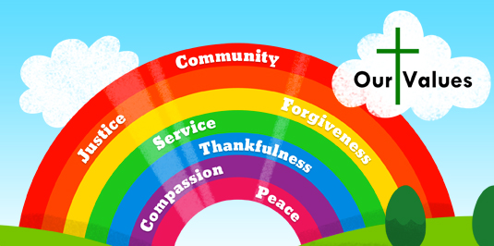
Our curriculum is connected between the teaching, learning and opportunity for transferable knowledge, skills, experience and vocabulary that enable each of our pupils to flourish. We are, as a collective, responsible for ensuring that we uphold these Christian values and teach them through the four domains of our curriculum for excellence. The British Values are also integrated within the teaching of our Christian Values, which are underpinned by our GROW standards. We believe that these are vital components in our aim to educate the whole person and desire to provide opportunity for life in all its fullness.
At each stage of the learning, we use talk led, metacognitive and collaborative approaches to support the learning journey and ‘Grow standards’, which are underpinned by cognitive science.
Our approach requires that our children need to have real and purposeful experiences of a key construct/concept in order to become enthused and engage with it. From this, the children then need to have the opportunity to play within the construct/concept at all ages.
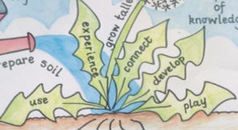
This includes daily retrieval practice and short burst games and activities to support fluency and confidence. The learning then will progress to using the learning and practising it in context via practical application, before developing the learning so that our children can articulate their learning to others. We then endeavour to connect the learning across the curriculum and provide opportunities for children to apply their learning to other contexts. This, in our view, is the true evidence of profound learning for all our pupils with the shared ambition that the learning is irresistible and ‘sticks’ and stays with them forever.
Grow taller and stronger
Teachers are responsible for ensuring feedback leads to improvements in learning. It should build self-esteem, encourage and motivate, support development, be relevant to the aims of the lesson and lead to progress (see our feedback policy). This is the part of our learning cycle where our children are now moving towards independence. We aim to support children in recognising where their abundance of life flows from and provide opportunities to celebrate this.
At Eye we will:
- Provide opportunities for self-assessment so children know their level of success.
- Allow for marking of own work, e.g. using answer sheets and fast track passes.
- Have feedback with the teacher or TA to evaluate own learning.
- Use of green pen to edit and improve work.
- Provide feedback on learning for pupils in line with the school’s feedback policy.
- Identify next steps in learning for groups of learners.
- Encourage reflection for children to know their own next steps.
- Identify any gaps in learning for intervention and/or impact sessions.
- Celebrate achievement of all children.
Dispersal of knowledge

When learning is truly embedded, then skills, vocabulary and knowledge can be used and transferred in different contexts and subject areas. This is connected and profound learning, and evidence of the impact of our teaching and our curriculum ambition.

We will endeavour to:
- Provide opportunities to apply learning in a different context; away from the point of learning.
- Use regular low stakes quizzing, away from the point of learning.
- Provide MTPs that reflect the skills taught previously so that children are building on their prior learning and the knowledge is cumulative.
- Provide purposeful tasks that demonstrate children’s application of skills across the curriculum.

The role of the church in teaching and learning
The church is an integral part of our school. As a Church of England school, our Christian values are celebrated and developed through a shared language and behaviour modelled by all staff. Our Christian Values are displayed in each classroom and are explicitly modelled within our collective worship, linking to the British Values. Each half term, there is a different value emphasis. These values are also referred to throughout our curriculum learning where appropriate.
The church supports the teaching and learning of our pupils by:
- Leading a weekly collective worship linked to the church calendar, our Christian Values or our ‘Understanding Christianity’ religious education (RE) unit of work.
- Organising theme days for religious education with church volunteers to steer workshops and lead on a specific learning theme.
- Supporting the school in organising frequent church services at St. Matthew’s church for the whole school community to attend.
- The vicar of St Matthew’s is also a governor at our school and therefore attends important curriculum and T&L updates at these meetings. [July 2024 Update- now a vacancy within the church due to retirement.]
- Making up part of our Church School Group, which meets regularly throughout the school year in order to reflect on the effectiveness of the church school and plan for development and improvement.
- Attending training and sharing training from The Diocese of Peterborough.

The role of parents in teaching and learning
We believe that parents have a fundamental role to play in helping children to learn. We do all we can to inform parents about what and how their children are learning by:
- Holding Termly Learning Conferences to explain our school strategies for teaching and learning and to provide information about children’s attainment.
- Sending information to parents at the start of each term in which we outline the curriculum that the children will be studying.
- Sending annual reports to parents in which we explain the progress made by each child and indicate how the child can improve further.
- Explaining to parents how they can support their children with home learning.
- Directing parents to the school website to learn more information about a particular area.
- Attending parent workshops that are devised by curriculum leaders.
- Social media pages i.e. Facebook.
We believe that parents have the responsibility to support their children and the school in implementing school policies. We would like parents to:
- ensure that their child has the best attendance record possible;
- ensure that their child is equipped for school with the correct uniform and PE and Forest School kit;
- do their best to keep their child healthy and fit to attend school;
- inform school if there are matters outside of school that are likely to affect child’s performance or behaviour at school;
- promote a positive attitude towards school and learning in general;
- fulfil the requirements set out in the home/school agreement.

The role of Governors in teaching and learning
The school’s governors determine, support, monitor and review the school policies on teaching and learning. In particular they:
- support the use of appropriate teaching strategies by allocating resources effectively;
- ensure that the school buildings and premises are best used to support successful teaching and learning;
- monitor teaching strategies in the light of health and safety regulations;
- monitor the effectiveness of the school’s teaching and learning policies through the school’s self-review processes;
- challenge and question the reports that they receive from subject leaders which gives them information about the current status of their subject;
- provide challenge in the implementation of the school development plan, evaluate and advise on schemes of work and reviews policies;
- provide challenge upon receipt of a termly head teacher’s report;
- ensure that the church links remain strong;
- carry out focused visits to the school to look at a specific aspect of teaching and learning.

Appendix 1
Evidence informed and responsively planned professional development package for all staff at Eye:

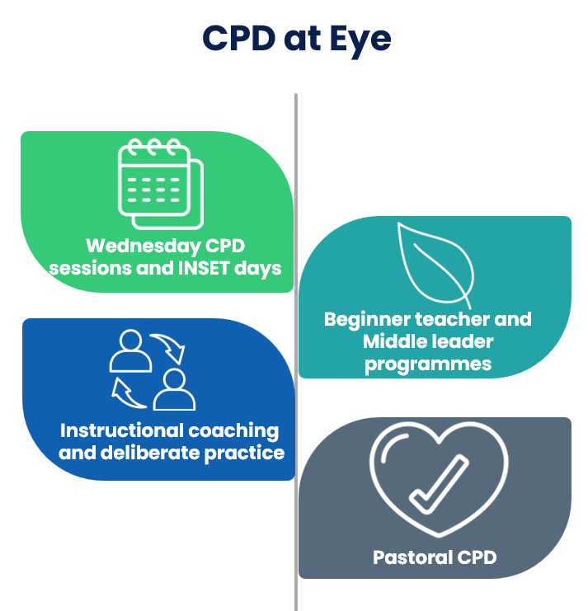

Appendix 2
Bi-weekly Instructional coaching cycle
Instructional coaching involves one teacher working with another teacher, to help them take small, personalised steps to improve their practice. Instructional coaches help their teachers to get better by doing two things on a regular basis:
- Identifying an area for improvement usually based on a short observation.
- Providing teachers with opportunities to rehearse, get feedback, and make a habit of their improvement.
In the observation phase, the instructional coach will often drop in to the teacher’s lesson for about 15 minutes. This is a chance to see how their teacher is getting on and identify the next best small step for them to work on. Instructional coaching observations are about developing teachers, not judging them.
In the feedback phase, the instructional coach and the teacher get together for a structured meeting lasting about 30 minutes. During this time, the instructional coach leads the teacher through 3 activities designed to help them to improve:
- Providing the teacher with praise on any progress they have made.
- Agreeing the next best step for them to work on, before modelling the step to help the teacher develop an understanding of ‘what good looks like’.
- Helping the teacher to plan and rehearse their step, just as they’ll use it in their classroom.
Coaching works best when we focus on small changes. Steps work best when they accumulate over time to help teachers achieve a bigger teaching goal.
During rehearsal, teachers typically try out their step multiple times, with the coach giving balanced feedback between each round. Rehearsal in this low-stakes environment allows teachers to focus all their attention on improving, so they can begin to master their step before taking it to the demanding environment of the classroom.
The instructional coach then books in some time to observe the teacher using their step, and the cycle starts again. Here’s a diagram of the whole instructional coaching model: 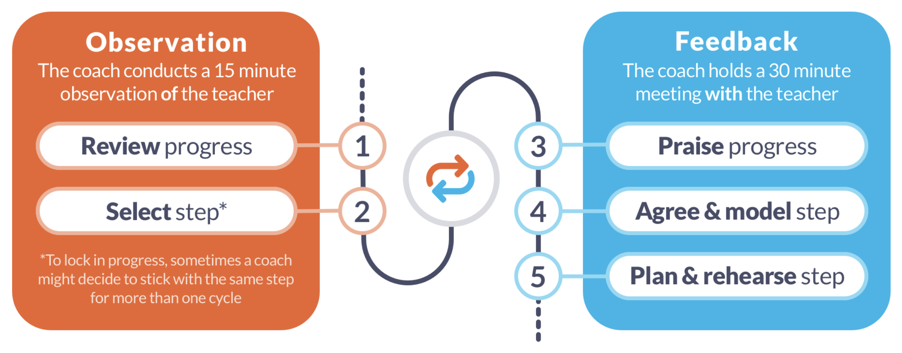

Appendix 3
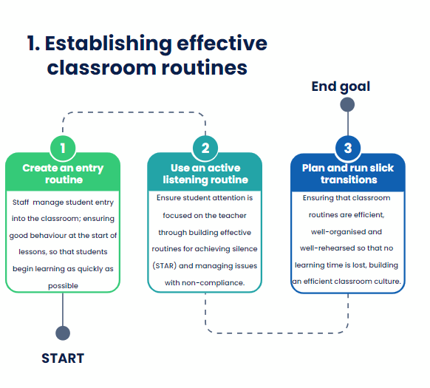
Our ‘Growth goals’ for effective teaching and learning at Eye



