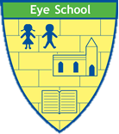

Physical Education at Eye CE Primary School

Our Aim
At Eye CE Primary School, our aim for Physical Education is to provide a curriculum that is ambitious, inclusive, and broad, enabling all pupils to enjoy and succeed in a range of physical activities. Through our PE provision, we aim to inspire a love for physical fitness, teamwork, and sportsmanship while promoting our GROW standards of Gratitude, Respect, Ownership and Wisdom.
We are committed to ensuring that our PE curriculum is well-structured, progressive, and tailored to the needs of our pupils. It is designed to develop physical skills, promote mental well-being, and instil lifelong habits of healthy living. By offering a diverse range of activities, we seek to engage all pupils, including those with varying levels of ability and interests, fostering a positive attitude towards physical activity that extends beyond the school environment.

Our school definition of Physical Education
Physical Education is the study of developing our physical competence and knowledge of movement and safety, and our ability to use these to perform in a wide range of activities associated with the development of an active and healthy lifestyle. In PE, we are moving to learn and learning to move.

How we do this
Our implementation strategy focuses on delivering high-quality PE lessons that are both challenging and enjoyable, led by, or supported by specialist teachers who are passionate about physical education. Through collaborative planning and regular assessment, we ensure that lessons are adapted to meet the needs of individual learners, providing appropriate support and extension opportunities where necessary.
In addition to curriculum lessons, which focus on fewer things in greater depth, we offer a wealth of extracurricular sports clubs, inter-school competitions, supplementary forest school and swimming on a 6-week rotation, and opportunities for pupils to engage in leadership roles, such as sports ambassadors. This holistic approach to PE not only enhances physical skills but also develops social, emotional, and leadership qualities amongst our pupils.
We believe in the importance of linking PE to other areas of the curriculum, such as science for instance, and using cross-curricular opportunities to reinforce learning and demonstrate the real-world applications of physical activity where purposeful. Our partnership with local sports clubs, coaches, and community organisations further enriches the PE experience for our pupils, offering access to a wide range of sports and physical pursuits.
Pupils have at least 2 hours of taught PE a week, as well as Forest School or Swimming on a 6-week rotation.
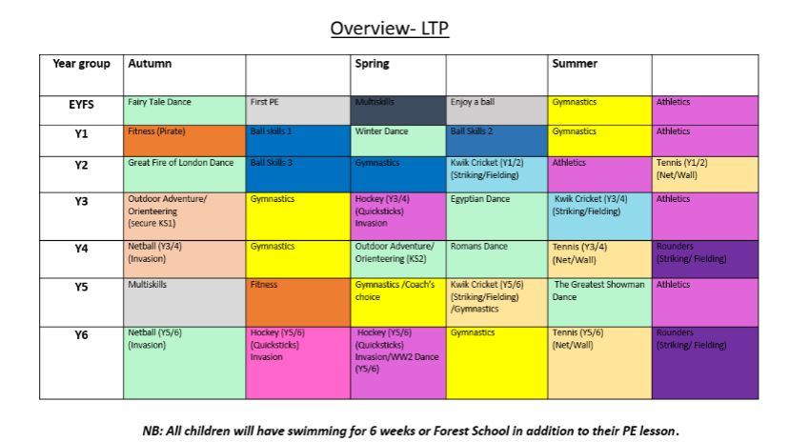

Outcomes
The impact of our PE provision is evidenced through the physical, social, and emotional development of our pupils. Through regular assessment and feedback mechanisms, we track the progress of individual pupils, celebrating achievements and identifying areas for improvement. This data informs our future planning, ensuring that our PE curriculum remains dynamic and responsive to the needs of our pupils.
Our pupils demonstrate high levels of engagement, enjoyment, and progress in PE, with many showcasing exceptional skills, sportsmanship, and leadership qualities. The positive attitudes towards physical activity fostered at our school extend beyond the classroom, leading to healthier lifestyles and increased participation in extracurricular sports and community events.
The impact of our PE programme not only benefits the physical well-being of our pupils, but also contributes to their overall personal development and academic success, reflecting our dedication to excellence in all areas of learning.

Alignment with our vision and values / opportunities for developing spirituality
Physical Education (PE) plays a crucial role in aligning with the school’s vision of "living life in all its fullness" as inspired by John 10:10. This vision emphasises holistic development, encouraging students to thrive not only academically but also physically, emotionally, and spiritually.
Living Life in All Its Fullness through PE:
- Holistic Well-being: PE supports students' physical health, which is foundational for a fulfilling life. Regular physical activity promotes physical fitness, mental well-being, and emotional balance, enabling students to engage fully in all aspects of life.
- Character Building: Through PE, students learn essential life skills such as teamwork, perseverance, resilience, and fair play. These values contribute to a well-rounded character, helping them navigate challenges and opportunities in life.
- Joy and Fulfillment: Engaging in sports and physical activities allows students to experience joy, satisfaction, and a sense of achievement, contributing to their overall sense of well-being and fulfillment.
Opportunities for Spiritual Development:
- Reflection and Mindfulness: PE often incorporates elements of reflection, such as considering personal progress or understanding the importance of rest and recovery. These practices can help students develop mindfulness, an important aspect of spirituality.
- Sense of Community: Participating in team sports and group activities fosters a sense of belonging and community, reflecting the spiritual value of connectedness and the importance of relationships.
- Respect for the Body: PE teaches students to respect and care for their bodies, which can be seen as a way of honoring the gift of life, a concept deeply rooted in spiritual understanding.
Overall, PE provides students with a dynamic environment to develop their physical abilities, cultivate important life values, and explore their spirituality, all of which contribute to living life in its fullness as envisioned by the school.

July 2024

