Term | English Sequences
Term | Pathways to Write | Poetry Units and Cross-Curricular Writing | Other rhymes, songs and poems to study | Scaffolded reading texts | Story time texts
1 – 7 weeks | Unit: Lost and Found by Oliver Jeffers - resistant text  Outcome: write an adventure story (fiction)  (approximately 4 weeks) | Poetry Unit: Sea Songs  (approximately 1 week)  Cross-curricular writing outcome: PSHE – linked to the topic of ‘Family and Relationships’.  (approximately 1 week) | Two Little Dicky Birds  10 in the Bed | A decodable book that matches the GPCs that pupils have already encountered in their Sounds-Write phonics lessons.  Sensible rule: choose a book that focuses on the GPCs introduced in the previous ~6 weeks | The Wonky Donkey by Craig Smith - enjoyable text, reading for pleasure  I Am Enough by Grace Byers – BAME
2 – 7 weeks | Unit: Nibbles: The Book Monster by Emma Yarlett  Outcome: write a diary entry (recount)  (approximately 4 weeks) | Poetry Unit: There Are No Such Things as Monsters!! by  Roger Stevens  (approximately 1 week) | Here’s the Church and Here’s the Steeple  Alice the Camel  Dingle Dangle Scarecrow | A decodable book that matches the GPCs that pupils have already encountered in their Sounds-Write phonics lessons.  Sensible rule: choose a book that focuses on the GPCs introduced in the previous ~6 weeks | Burglar Bill by Janet and Allan Ahlberg - enjoyable text, reading for pleasure  Silly Billy by Anthony Browne - enjoyable text, reading for pleasure
3 – 6 weeks | Unit: The Lion Inside by Rachel Bright  Outcome: write a story (fiction)  (approximately 4 weeks) | Poetry Unit: If I Had a Beak by The Literacy Company  (approximately 1 week)  Cross-curricular writing outcome: History – linked to the topic of ‘History of transport’.  (approximately 1 week) | Hey Diddle Diddle  Hickory Dickory Dock  There Was An Old Lady Who Swallowed A Fly | A decodable book that matches the GPCs that pupils have already encountered in their Sounds-Write phonics lessons.  Sensible rule: choose a book that focuses on the GPCs introduced in the previous ~6 weeks | The Man on the Moon by Simon Bartram - enjoyable text, reading for pleasure  Isaac and Iris by Catherine Rayner - enjoyable text, reading for pleasure
4 – 6 weeks | Unit: The Curious Case of the Missing Mammoth by Ellie Hattie, A Great Big Cuddle By Michael Rosen  Outcome: write a letter to a historical figure (recount)  (approximately 4 weeks) | Poetry Unit: At the Zoo by W. M. Thackeray  (approximately 1 week) | Kookaburra Sits in the Old Gum Tree  Miss Polly Had a Dolly  Horsie, Horsie | A decodable book that matches the GPCs that pupils have already encountered in their Sounds-Write phonics lessons.  Sensible rule: choose a book that focuses on the GPCs introduced in the previous ~6 weeks | The Enchanted Wood by Enid Blyton - cumulative tale  Funny Bones by Janet and Allan Ahlberg - enjoyable text, reading for pleasure
5 – 5 weeks | Unit: Toys in Space by Mini Grey  Outcome: write a story (fiction)  (approximately 4 weeks) | Poetry Unit: I Spun a Star by John Foster  (approximately 1 week) | A Sailor went to Sea, Sea, Sea  Sing A Song of Sixpencee | The Tiger Who Came To Tea by Judith Kerr*– complexity of plot/symbol  Beegu by Alexis Deacon*  Avocado Baby by John Burningham*  The Colour Monster by Anna Llenas – resistant text  A decodable book that matches the GPCs that pupils have already encountered in their Sounds-Write phonics lessons. | Don’t touch my hair by Sharee Miller – PSHE links
6 – 7 weeks | Unit: Goldilocks and Just the One Bear by Leigh Hodgkinson  Outcome: write a report about bears (non-fiction)  (approximately 4 weeks) | Poetry Unit: Poetry Fruit Salad  (approximately 1 week)  Cross-curricular writing outcome: RE – linked to the topic of ‘How should we care for the world and for others, and why does it matter?’  (approximately 1 week) | London Bridge  Oranges and Lemons | Peace at Last by Jill Murphy*  Can’t you sleep little bear? By Martin Waddell*  Dogger by Shirley Hughes*  Cops and Robbers by Janet and Allan Ahlberg*  A decodable book that matches the GPCs that pupils have already encountered in their Sounds-Write phonics lessons.  *age-appropriate texts on Pie Corbett’s reading spine | Elmer by David McKee -  beginnings of diversity
Year 1 Mastery Keys

Year 1 | Autumn 1 | Autumn 2 | Spring 1 | Spring 2 | Summer 1 | Summer 2
Year 1 | Word | Word  Use plural noun suffixes -s and -es | Word  Add suffixes where no change is needed to the root of the word e.g. -ed, -ing, -er, -est  Some accurate use of the prefix un- | Word  Add suffixes where no change is needed to the root of the word e.g. -ed, -ing, -er, -est | Word  Add suffixes where no change is needed to the root of the word e.g. -ed, -ing, -er, -est  Change the meaning of verbs/ adjectives by adding prefix un- | Word
Year 1 | Word  Throughout each unit of Pathways to Write there will be opportunities to teach and apply word skills:  Spell words containing each of the 40+ phonemes already taught and spell common exception words
Year 1 | Sentence  Combine words to make sentences | Sentence  Join words using and | Sentence  Join words and clauses using and | Sentence  Join words and clauses using and | Sentence  Join words and clauses using and | Sentence  Join words and clauses using and  Use simple description
Year 1 | Text | Text  Sequence sentences (link ideas or events by pronoun) | Text | Text | Text | Text  Sequence sentences to form short narratives (link ideas or events by pronouns)
Year 1 | Punctuation  Leave spaces between words  Begin to use capital letters and full stops  Use a capital letter for names of people and the personal pronoun ‘I’ | Punctuation  Punctuate sentences using a capital letter and a full stop  Use capital letters for names of people and places | Punctuation  Punctuate sentences using a capital letter and a full stop, some question marks and exclamation marks | Punctuation  Punctuate sentences using a capital letter and a full stop, question mark or exclamation mark | Punctuation  Punctuate sentences using a capital letter and a full stop, question mark or exclamation mark | Punctuation  Use capital letter for names of people and places  Punctuate sentences using a capital letter, full stop, question mark or exclamation mark

Please see the progression documents for text features and grammar on the server. You can also use these documents to ‘track back’ to support your learners. There are also reading & speaking and listening progression documents there too.

Y1 Assessment Matrix

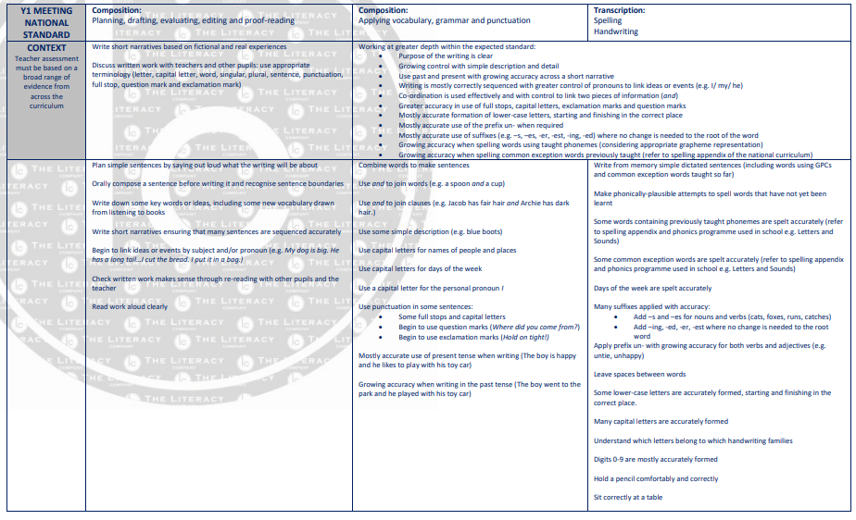

Pathways to Poetry
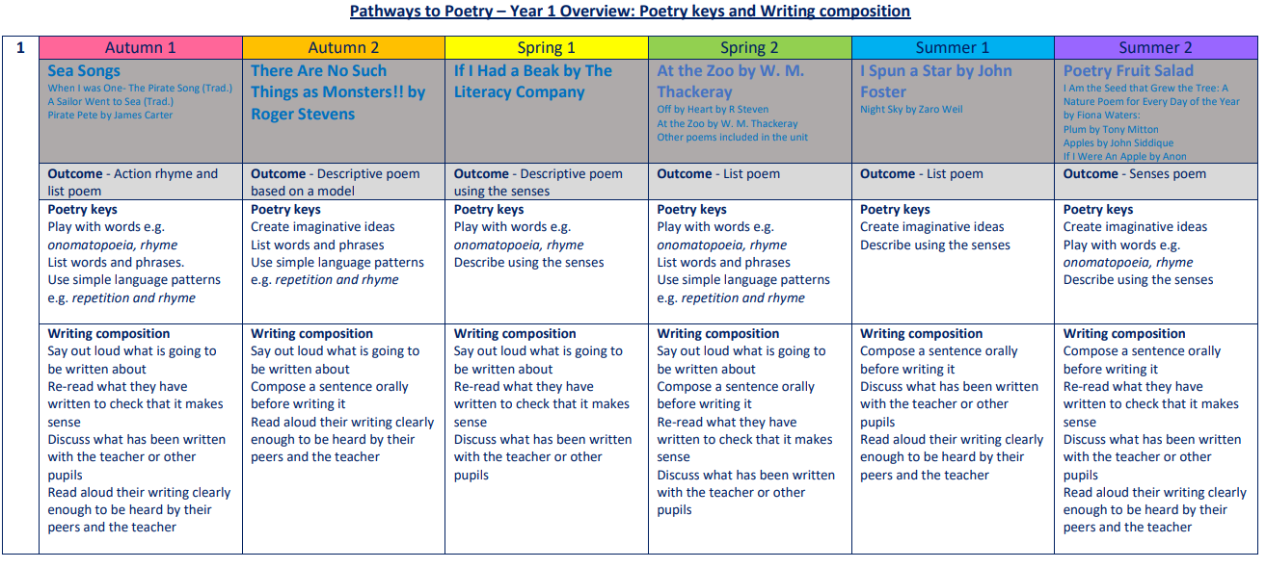

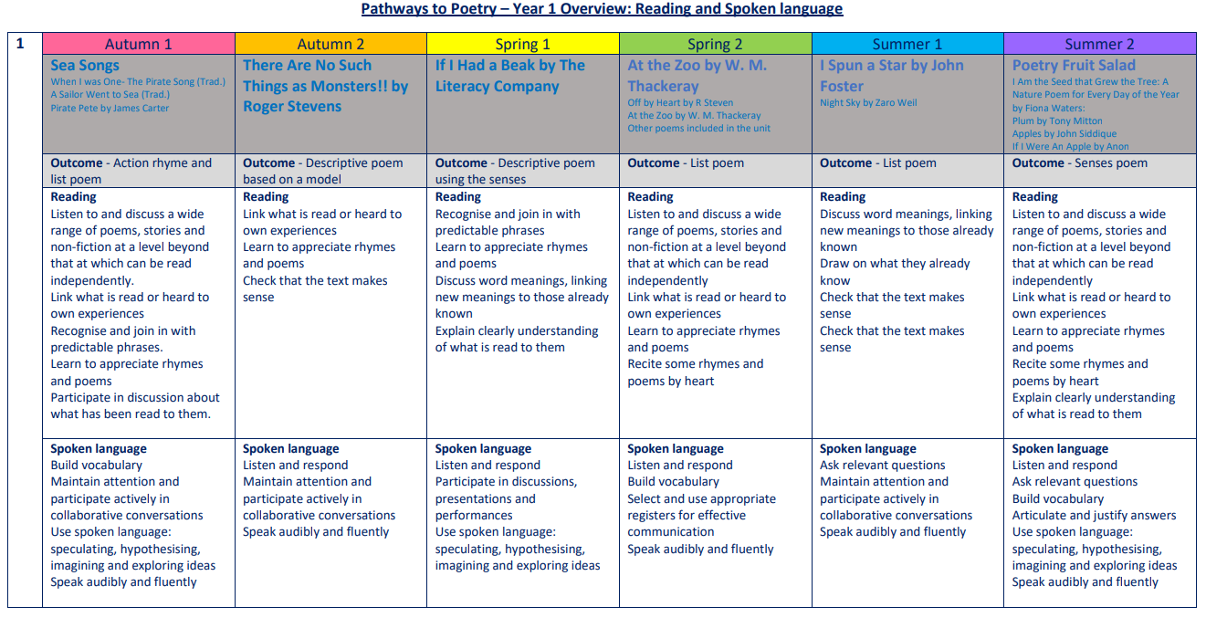

Year 1: Suggested Weekly Reading Sequence
Session 1 | Session 2 | Session 3 | Session 4 | Session 5
Scaffolded Reading | Scaffolded Reading | Scaffolded Reading | Scaffolded Reading | Scaffolded Reading

