Term | English Sequences |  | Reading Sequences | Story time texts
Term | Pathways to Write | Poetry Units and Cross-Curricular Writing | Reading Sequences | Story time texts
1 – 7 weeks | Unit: Troll Swap by Leigh Hodgkinson, Trolls Go Home by Alan MacDonald  Outcome: write a story (fiction)  (approximately 4 weeks) | Poetry Unit: Zebra Question by Shel Silverstein  (approximately 1 week)  Cross-curricular writing outcome: History – linked to the topic of ‘The Great Fire of London’.  (approximately 1 week) | RE: Ramadan and Eid al-Fitr by Melissa Ferguson – links to topic ‘Who Is Muslim and how do they live? 1’ | Winnie-The-Pooh by A.A. Milne – archaic text
1 – 7 weeks |  |  | Geography: Unit information text on the server linked to current/recent topic.  See Inside Where Food Comes from by Emily Bone - links to autumn geography learning | Winnie-The-Pooh by A.A. Milne – archaic text
1 – 7 weeks |  |  | History: Unit information text on the server linked to current/recent topic.  The Great Fire of London by Emma Adams - links to autumn history learning | Winnie-The-Pooh by A.A. Milne – archaic text
1 – 7 weeks |  |  | Science: Unit information text on the server linked to current/recent topic.  Everyday Materials by Ruth Owen - links to autumn science learning | Winnie-The-Pooh by A.A. Milne – archaic text
1 – 7 weeks |  |  | Wider curriculum: Choose from wider curriculum KS2 box. | Winnie-The-Pooh by A.A. Milne – archaic text
1 – 7 weeks |  |  | Other: How to Hide a Lion by Helen Stephens - recommended Y2 text by LA | Winnie-The-Pooh by A.A. Milne – archaic text
2 – 7 weeks | Unit: The Owl Who Was Afraid of The Dark by Jill Tomlinson – non-linear  Outcome: write a report (non-fiction)  (approximately 4 weeks) | Poetry Unit: The Owl and the Pussycat by Edward Lear  (approximately 1 week)  Reading and SPAG assessments to be administered (approximately 2 lessons) | RE: What is Christmas: The True Meaning of Christmas by Elena Alber - links to topic ‘Why does Christmas matter?’ | Winnie-The-Pooh by A.A. Milne – archaic text
2 – 7 weeks |  |  | Geography: Unit information text on the server linked to current/recent topic.  Welcome to Our Table: A Celebration of What Children Eat Everywhere - links to autumn geography learning | Winnie-The-Pooh by A.A. Milne – archaic text
2 – 7 weeks |  |  | History: Unit information text on the server linked to current/recent topic.  The Great Fire of London by Susanna Davidson - links to autumn history learning | Winnie-The-Pooh by A.A. Milne – archaic text
2 – 7 weeks |  |  | Science: Unit information text on the server linked to current/recent topic.  Solid, liquid or gas? By Jane Lacey - links to autumn science learning | Winnie-The-Pooh by A.A. Milne – archaic text
2 – 7 weeks |  |  | Wider curriculum: Choose from wider curriculum KS2 box. | Winnie-The-Pooh by A.A. Milne – archaic text
2 – 7 weeks |  |  | Other: Super Sid the Silly Sausage Dog by Sam Lloyd - recommended Y2 text by LA | Winnie-The-Pooh by A.A. Milne – archaic text
3 – 6 weeks | Unit: The Dragon Machine by Helen Ward, How to Train Your Dragon (2010 film), The Dragonsitter by Josh Lacey  Outcome: write a story with an adventure focus (fiction)  (approximately 4 weeks) | Poetry Unit: From a Railway Carriage by Robert Louis Stevenson  (approximately 1 week)  Cross-curricular writing outcome: Science – linked to the topic of ‘Living things and life cycles’.  (approximately 1 week) | RE: But...Who is Allah?: (Islamic books for kids) – links to topic ‘What is Muslim and how do they live? 2’ | The Stinky Cheese Man and Other Fairly Stupid Tales – non-linear time sequence
3 – 6 weeks |  |  | Geography: Unit information text on the server linked to current/recent topic.  Weird But True! USA by National Geographic Kids - links to spring geography learning
3 – 6 weeks |  |  | History: Unit information text on the server linked to current/recent topic.  Florence Nightingale (Ways Into History) - links to spring history learning
3 – 6 weeks |  |  | Science: Unit information text on the server linked to current/recent topic.  Growing and Changing: All About Life Cycles by Ruth Owen - links to spring science learning
3 – 6 weeks |  |  | Wider curriculum: Choose from wider curriculum KS2 box.
3 – 6 weeks |  |  | Other: A Squash and a Squeeze by Julia Donaldson - recommended Y2 text by LA
4 – 6 weeks | Unit: My Name is Not Refugee by Kate Milner  Outcome: write a recount of events from character’s point of view (recount)  (approximately 4 weeks) | Poetry Unit: Night Sounds by Berlie Doherty  (approximately 1 week)  Reading and SPAG assessments to be administered (approximately 2 lessons) | RE: The Easter Story by Katherine Sully – ‘links to topic ‘Why does Easter matter to Christians?’
4 – 6 weeks |  |  | Geography: Unit information text on the server linked to current/recent topic.  South America (Continents Uncovered) - links to spring geography learning
4 – 6 weeks |  |  | History: Unit information text on the server linked to current/recent topic.  Brave Nurses: Mary Seacole and Edith Cavell - links to spring history learning
4 – 6 weeks |  |  | Science: Unit information text on the server linked to current/recent topic.  The Egg Book: See How Baby Animals Hatch, Step By Step! By DK - links to spring science learning
4 – 6 weeks |  |  | Wider curriculum: Choose from wider curriculum KS2 box.
4 – 6 weeks |  |  | Other: The Gruffalo’s Child by Julia Donaldson - recommended Y2 text by LA
5 – 5 weeks | Unit: The Last Wolf by Mini Grey  Outcome: write a letter in role (recount)  (approximately 4 weeks) | Poetry Unit: Father and I in the Woods by David McCord  (approximately 1 week) | RE: Jesus Storybook Bible – links to topic ‘What is the good news that Jesus brings?’ | Fantastic Mr Fox by Roald Dahl – complexity of the narrator
5 – 5 weeks |  |  | Geography: Unit information text on the server linked to current/recent topic.  National Trust: Look What I Found at the Seaside - links to summer geography learning | Fantastic Mr Fox by Roald Dahl – complexity of the narrator
5 – 5 weeks |  |  | History: Unit information text on the server linked to current/recent topic.  A Place Called Home: Look Inside Houses Around the World - links to summer history learning | Fantastic Mr Fox by Roald Dahl – complexity of the narrator
5 – 5 weeks |  |  | Science: Unit information text on the server linked to current/recent topic.  Powered by Plants by Clive Gifford - links to summer science learning | Fantastic Mr Fox by Roald Dahl – complexity of the narrator
5 – 5 weeks |  |  | Wider curriculum: Choose from wider curriculum KS2 box. | Fantastic Mr Fox by Roald Dahl – complexity of the narrator
5 – 5 weeks |  |  | Other: The Great Fairytale Disaster by David Conway and Melanie Williamson - recommended Y2 text by LA | Fantastic Mr Fox by Roald Dahl – complexity of the narrator
6 – 7 weeks | Unit: Grandad’s Secret Giant by David Litchfield  Outcome: write a story with a moral focus (fiction)  (approximately 4 weeks) | Poetry Unit: Fox by Kathy Henderson (approximately 1 week)  Cross-curricular writing outcome: Geography – linked to the topic ‘Coastlines’.  (approximately 1 week)  Reading and SPAG assessments to be administered (approximately 2 lessons) | RE: Ways Into RE: Places of Worship – links to topic ‘What makes some places sacred to believers?’ | Fantastic Mr Fox by Roald Dahl – complexity of the narrator
6 – 7 weeks |  |  | Geography: Unit information text on the server linked to current/recent topic.  Above and Below: Sea and Shore by Harriet Evans - links to summer geography learning | Fantastic Mr Fox by Roald Dahl – complexity of the narrator
6 – 7 weeks |  |  | History: Unit information text on the server linked to current/recent topic.  National Trust: Step Inside Homes Through History - links to summer history learning | Fantastic Mr Fox by Roald Dahl – complexity of the narrator
6 – 7 weeks |  |  | Science: Unit information text on the server linked to current/recent topic.  The Secret World of Plants by Ben Hoare - links to summer science learning | Fantastic Mr Fox by Roald Dahl – complexity of the narrator
6 – 7 weeks |  |  | Wider curriculum: Choose from wider curriculum KS2 box. | Fantastic Mr Fox by Roald Dahl – complexity of the narrator
6 – 7 weeks |  |  | Other: My Teacher Is A Monster by Peter Brown - recommended Y2 text by LA | Fantastic Mr Fox by Roald Dahl – complexity of the narrator

Year 2 Mastery Keys
Year 2 | Autumn 1 | Autumn 2 | Spring 1 | Spring 2 | Summer 1 | Summer 2
Year 2 | Word | Word  Add -ly to turn adjectives into adverbs | Word | Word | Word  Add -er and -est to adjectives  Use homophones and near homophones | Word  Add suffixes to spell longer words (e.g -ment,- ful)
Year 2 | Word  Throughout each unit of Pathways to Write there will be opportunities to apply word skills:  Spell many words correctly by segmenting spoken words into phonemes and representing these by graphemes and spell common exception words.
Year 2 | Sentence  Use subordination (because) and co-ordination (and)  Use expanded noun phrases to describe and specify | Sentence  Use co-ordination (but, or) | Sentence  Write sentences with different forms: statement, question, exclamation, command  Use subordination (apply because, introduce when) | Sentence  Use subordination (apply because, when; introduce that) | Sentence  Use subordination (if, that) | Sentence  Use subordination (when, if, that, because) and co-ordination (or, and, but)  Use expanded noun phrases to describe and specify
Year 2 | Text | Text | Text  Use present and past tenses correctly and consistently (some progressive) | Text  Use present and past tenses correctly and consistently  Use the progressive form of verbs in the present and past tense | Text | Text  Use present and past tenses correctly and consistently including the progressive form
Year 2 | Punctuation  Use punctuation correctly - full stops, capital letters | Punctuation  Use commas to separate items in a list | Punctuation  Use punctuation correctly - exclamation marks, question marks | Punctuation  Use punctuation correctly – introduce apostrophe for the possessive (singular) | Punctuation  Use punctuation correctly – apostrophes for contracted forms | Punctuation

Please see the progression documents for text features and grammar on the server. You can also use these documents to ‘track back’ to support your learners. There are also reading & speaking and listening progression documents there too.

Year 2 Assessment Matrix
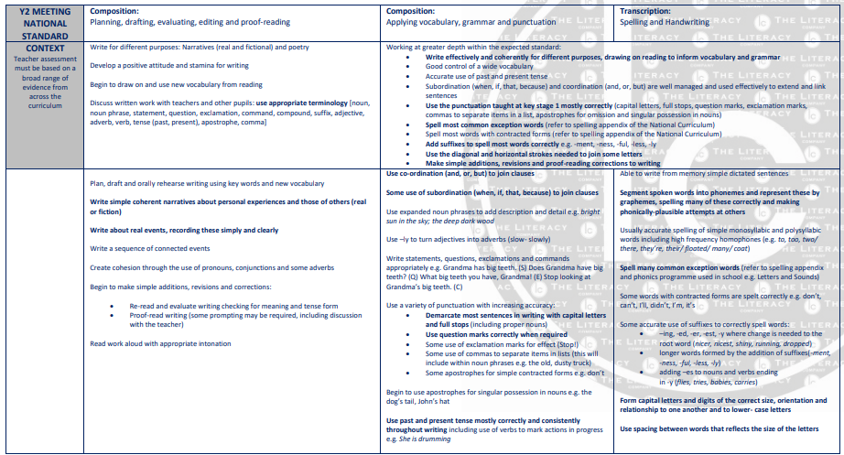

Pathways to Poetry
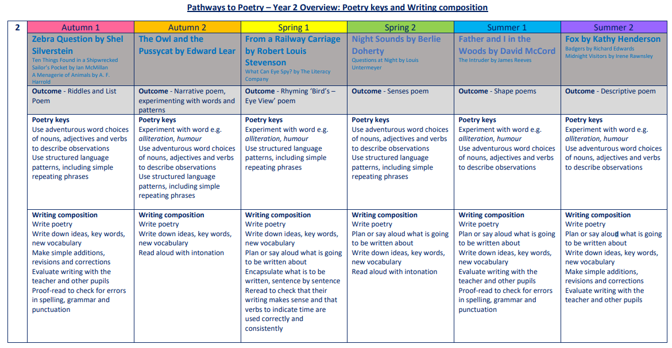

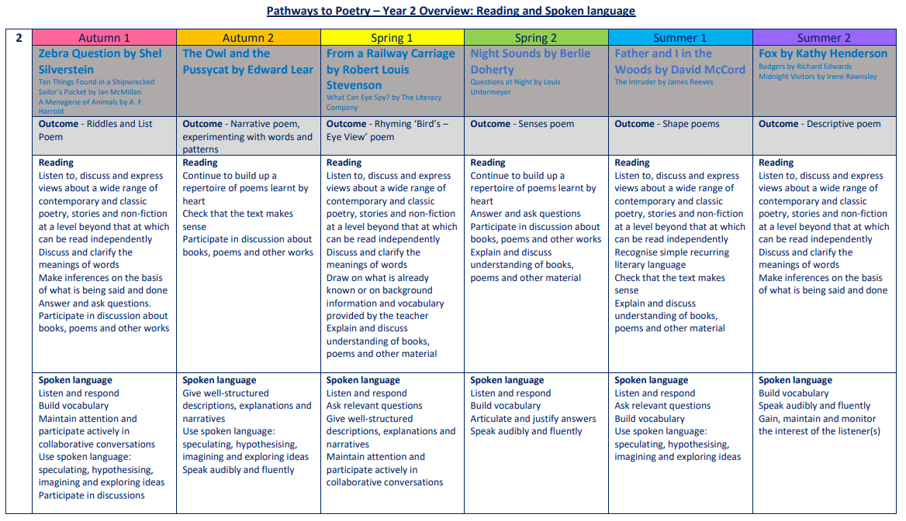

The Five Plagues of the Developing Reader
In his book ‘Reading Reconsidered’, Doug Lemov points out that there are five types of texts that children should have access to in order to successfully navigate reading with confidence. These are complex beyond a lexical level and demand more from the reader than other types of books.
Archaic Language
The vocabulary, usage, syntax and context for cultural reference of texts over 50 or 100 years old are vastly different and typically more complex than texts written today. Students need to be exposed to and develop proficiency with antiquated forms of expression to be able to hope to read James Madison, Frederick Douglass and Edmund Spenser when they get to college.
Non-Linear Time Sequences
In passages written exclusively for students—or more specifically for student assessments— time tends to unfold with consistency. A story is narrated in a given style with a given cadence and that cadence endures and remains consistent, but in the best books, books where every aspect of the narration is nuanced to create an exact image, time moves in fits and start. It doubles back. The only way to master such books is to have read them time and again and to be carefully introduced to them by a thoughtful teacher or parent.
Narratively Complex
Books are sometimes narrated by an unreliable narrator- Scout, for example, who doesn’t understand and misperceives some of what happened to her. Or the narrator in Edgar Allan Poe’s “The Tell-Tale Heart” who is a madman out of touch with reality. Other books have multiple narrators such as Faulkner’s As I Lay Dying. Others have non-human narrators such as the horse that tells the story in Black Beauty. Some books have multiple intertwined and apparently (for a time) unrelated plot lines. These are far harder to read than books with a single plot line and students need to experience these as well.
Figurative/Symbolic Text
Texts which happen on an allegorical or symbolic level. Not reflected in Lexiles; critical forms of text complexity that students must experience.
Resistant Texts
Texts written to deliberately resist easy meaning-making by readers. Perhaps half of the poems ever written fall into this category. You have to assemble meaning around nuances, hints, uncertainties and clues.

Our reading spine acknowledges these barriers, and seeks opportunities to include exposure to these types of texts, as well as those that we believe are a pleasurable experience for our children to engage with.

Year 2: Suggested Weekly Reading Sequence
Session 1 | Session 2 | Session 3 | Session 4 | Session 5
Fluency Reading | Extended Reading | Fluency Reading | Extended Reading | Fluency Reading

