Term | English Sequences |  | Reading Sequences | Story time texts
Term | Pathways to Write | Poetry Units and Cross-Curricular Writing | Reading Sequences | Story time texts
1 – 7 weeks | Unit: Seal Surfer by Michael Foreman  Outcome: write a letter in role (recount)  (approximately 4 weeks) | Poetry Unit: The Shell by John Foster  (approximately 1 week)  Cross-curricular writing outcome: History – linked to the topic of ‘The Stone Age, the Bronze Age and the Iron Age’.  (approximately 1 week) | RE: The Creation Story for Children by David Haidle – links to topic ‘What do Christians learn from the Creation Story’ | The Witches by Roald Dahl – complexity of the narrator
1 – 7 weeks |  |  | Geography: Unit information text on the server linked to current/recent topic.  Cities Book by Lonely Planet Kids – links to autumn geography learning | The Witches by Roald Dahl – complexity of the narrator
1 – 7 weeks |  |  | History: Unit information text on the server linked to current/recent topic.  Stone Age to Iron Age by Clare Hibbert - links to autumn history learning | The Witches by Roald Dahl – complexity of the narrator
1 – 7 weeks |  |  | Science: Unit information text on the server linked to current/recent topic.  Rocks and Fossils by Struan Reid – links to topic ‘rocks and fossils’ | The Witches by Roald Dahl – complexity of the narrator
1 – 7 weeks |  |  | Wider curriculum: Choose from wider curriculum KS2 box. | The Witches by Roald Dahl – complexity of the narrator
1 – 7 weeks |  |  | Other: The Proudest Blue by Ibtihaj Muhammad - BAME | The Witches by Roald Dahl – complexity of the narrator
2 – 7 weeks | Unit: Nen and the Lonely Fisherman by Ian Eagleton  Outcome: write a fantasy story based on a classic tale (fiction)  (approximately 4 weeks) | Poetry Unit: Dance with Me, Autumn by The Literacy Company  (approximately 1 week)  Reading and SPAG assessments to be administered (approximately 2 lessons) | RE: What is God like? By Rachel Held Evans - links to topic ‘What is it like to follow God?’ | The Witches by Roald Dahl – complexity of the narrator
2 – 7 weeks |  |  | Geography: Unit information text on the server linked to current/recent topic.  The Big Book of the UK: Facts, folklore and fascinations from around the United Kingdom - links to autumn learning | The Witches by Roald Dahl – complexity of the narrator
2 – 7 weeks |  |  | History: Unit information text on the server linked to current/recent topic.  Everything: Stone Age to Iron Age by National Geographic Kids - links to autumn history learning | The Witches by Roald Dahl – complexity of the narrator
2 – 7 weeks |  |  | Science: Unit information text on the server linked to current/recent topic.  Forces and Magnets (Step Into Science) – links to topic ‘forces and magnets’ | The Witches by Roald Dahl – complexity of the narrator
2 – 7 weeks |  |  | Wider curriculum: Choose from wider curriculum KS2 box. | The Witches by Roald Dahl – complexity of the narrator
2 – 7 weeks |  |  | Other: The Christmas-saurus by Tom Fletcher - enjoyable text, reading for pleasure | The Witches by Roald Dahl – complexity of the narrator
3 – 6 weeks | Unit: Stone Age Boy by Katoshi Kitamura  Outcome: write a story set in the Stone Age (fiction)  (approximately 4 weeks) | Poetry Unit: The River’s Tale by Rudyard Kipling (extract)  (approximately 1 week)  Cross-curricular writing outcome: Science – linked to the topic of ‘Light and Shadow’.  (approximately 1 week) | RE: Amazing Muslims Who Changed the World by Burhana Islam - links to topic ‘How do festivals and worship show what matters to Muslims’ | The Iron Man by Ted Hughes – complexity of plot/symbol
3 – 6 weeks |  |  | Geography: Unit information text on the server linked to current/recent topic.  7 Wonders of the World: A Book That Makes You Move - links to spring geography learning | The Iron Man by Ted Hughes – complexity of plot/symbol
3 – 6 weeks |  |  | History: Unit information text on the server linked to current/recent topic.  Egypt Magnified by David Long - links to spring history learning | The Iron Man by Ted Hughes – complexity of plot/symbol
3 – 6 weeks |  |  | Science: Unit information text on the server linked to current/recent topic.  Light (Step Into Science) – links to topic ‘light and shadows’ | The Iron Man by Ted Hughes – complexity of plot/symbol
3 – 6 weeks |  |  | Wider curriculum: Choose from wider curriculum KS2 box. | The Iron Man by Ted Hughes – complexity of plot/symbol
3 – 6 weeks |  |  | Other: Cinderella of the Nile by Beverley Naidoo - archaic language, links to Ancient Egypt history topic & links to a story the children know | The Iron Man by Ted Hughes – complexity of plot/symbol
4 – 6 weeks | Unit: Big Blue Whale by Nicola Davies, This Morning I Met a Whale by Michael Morpurgo  Outcome: write an information article (persuasion)  (approximately 4 weeks) | Poetry Unit: The Magnificent Bull from the Dinka tribe  (approximately 1 week)  Reading and SPAG assessments to be administered (approximately 2 lessons) | RE: Celebrating Jewish Festivals by Liz Miles - links to topic ‘How do festivals and family life show what matters to Jewish people?’ | The Iron Man by Ted Hughes – complexity of plot/symbol
4 – 6 weeks |  |  | Geography: Unit information text on the server linked to current/recent topic.  Where Were the Seven Wonders of the Ancient World? - links to spring geography learning | The Iron Man by Ted Hughes – complexity of plot/symbol
4 – 6 weeks |  |  | History: Unit information text on the server linked to current/recent topic.  Everything: Ancient Egypt (National Geographic Kids) - links to spring history learning | The Iron Man by Ted Hughes – complexity of plot/symbol
4 – 6 weeks |  |  | Science: Unit information text on the server linked to current/recent topic.  Thomas Edison: Level 3 (National Geographic Readers) - links to topic ‘light and shadows’ | The Iron Man by Ted Hughes – complexity of plot/symbol
4 – 6 weeks |  |  | Wider curriculum: Choose from wider curriculum KS2 box. | The Iron Man by Ted Hughes – complexity of plot/symbol
4 – 6 weeks |  |  | Other: How the Camel got his Hump by Rudyard Kipling – archaic text | The Iron Man by Ted Hughes – complexity of plot/symbol
5 – 5 weeks | Unit: Journey by Aaron Becker  Outcome: write an adventure story (narrative)  (approximately 4 weeks) | Poetry Unit: I Saw a Peacock by Anonymous  (approximately 1 week) | RE: The Friend Who Forgives Storybook: A true story about how Peter failed and Jesus forgave - links to RE topic | Mary Poppins by P.L. Travers – archaic text
5 – 5 weeks |  |  | Geography: Unit information text on the server linked to current/recent topic.  Amazon Basin by Simon Chapman - links to summer geography learning | Mary Poppins by P.L. Travers – archaic text
5 – 5 weeks |  |  | History: Unit information text on the server linked to current/recent topic.  The Indus Valley (Unlocking Ancient Civilisations) - links to summer history learning | Mary Poppins by P.L. Travers – archaic text
5 – 5 weeks |  |  | Science: Unit information text on the server linked to current/recent topic.  Powered by Plants by Clive Gifford – links to topic ‘plants and animals’ | Mary Poppins by P.L. Travers – archaic text
5 – 5 weeks |  |  | Wider curriculum: Choose from wider curriculum KS2 box. | Mary Poppins by P.L. Travers – archaic text
5 – 5 weeks |  |  | Other: Woof by Allan Ahlberg – complexity of the narrator | Mary Poppins by P.L. Travers – archaic text
6 – 7 weeks | Unit: Zeraffa Giraffa by Dianne Hofmeyr  Outcome: write a leaflet (persuasion)  (approximately 4 weeks) | Poetry Unit: Apes to Zebras (approximately 1 week)  Cross-curricular writing outcome: RE – linked to the topic ‘How and why do people try to make the world a better place?’  (approximately 1 week)  Reading and SPAG assessments to be administered (approximately 2 lessons) | RE: Rosa Parks: (Little People, Big Dreams) - links to topic ‘How and why do people try to make the world a better place?’ | Mary Poppins by P.L. Travers – archaic text
6 – 7 weeks |  |  | Geography: Unit information text on the server linked to current/recent topic.  Amazon: DK Eyewitness - links to summer geography learning | Mary Poppins by P.L. Travers – archaic text
6 – 7 weeks |  |  | History: Unit information text on the server linked to current/recent topic.  The Shang Dynasty and Yin (Time Travel Guides) - links to summer history learning | Mary Poppins by P.L. Travers – archaic text
6 – 7 weeks |  |  | Science: Unit information text on the server linked to current/recent topic.  Wilderness: Earth's Amazing Habitats - links to topic ‘plants and animals’ | Mary Poppins by P.L. Travers – archaic text
6 – 7 weeks |  |  | Wider curriculum: Choose from wider curriculum KS2 box. | Mary Poppins by P.L. Travers – archaic text
6 – 7 weeks |  |  | Other: Fantastically Great Women Who Changed the World by Kate Pankhurst – PSHE links, inspirational | Mary Poppins by P.L. Travers – archaic text
Year 3 Mastery Keys
Year 3 | Autumn 1 | Autumn 2 | Spring 1 |  | Spring 2 |  | Summer 1 | Summer 2
Year 3 | Word | Word  Use a or an according to whether the next word begins with a vowel or consonant | Word  Form nouns with a range of prefixes |  | Word | Word  Form nouns with a range of prefixes | Word  Use a or an according to whether the next word begins with a vowel or consonant | Word
Year 3 | Sentence  Use prepositions to express time, place and cause. | Sentence  Use conjunctions and adverbs to express, time, place and cause | Sentence | Sentence  Build an increasing range of sentence structures  Use adverbs to express time, place and cause | Sentence  Build an increasing range of sentence structures  Use adverbs to express time, place and cause | Sentence | Sentence  Use prepositions, conjunctions and adverbs to express time, place and cause | Sentence  Build an increasing range of sentence structures
Year 3 | Text  Group related ideas into paragraphs  Build a varied and rich vocabulary | Text  In narratives, create characters, settings and plot | Text  Use present and past tenses correctly and consistently including the progressive and present perfect forms  Build a varied and rich vocabulary | Text  Use headings and sub-  headings to aid presentation Assess the effectiveness of own and others’ writing | Text  Use headings and sub-  headings to aid presentation Assess the effectiveness of own and others’ writing | Text  Use present and past tenses correctly and consistently including the progressive and present perfect forms  Build a varied and rich vocabulary | Text  Group related ideas into paragraphs  Use the present perfect form of verbs in contrast to the past tense | Text  Use present and past tenses correctly and consistently including the progressive form and the present perfect form  In non-narrative material, use simple organisational devices including headings and sub-headings to aid presentation
Year 3 | Punctuation  Introduce inverted commas to punctuate direct speech | Punctuation  Use inverted commas to punctuate direct speech | Punctuation  Use inverted commas to punctuate direct speech | Punctuation | Punctuation | Punctuation  Use inverted commas to punctuate direct speech | Punctuation | Punctuation
*Set 1 *Set 2 *Please note that spring 1 and spring 2 mastery keys have been swapped in set 1 and set 2 Pathways to Write / *Objectives in italics are writing composition objectives. Please see the progression documents for text features and grammar on the server. You can also use these documents to ‘track back’ to support your learners. There are also reading & speaking and listening progression documents there too.
Year 3 Assessment Matrix
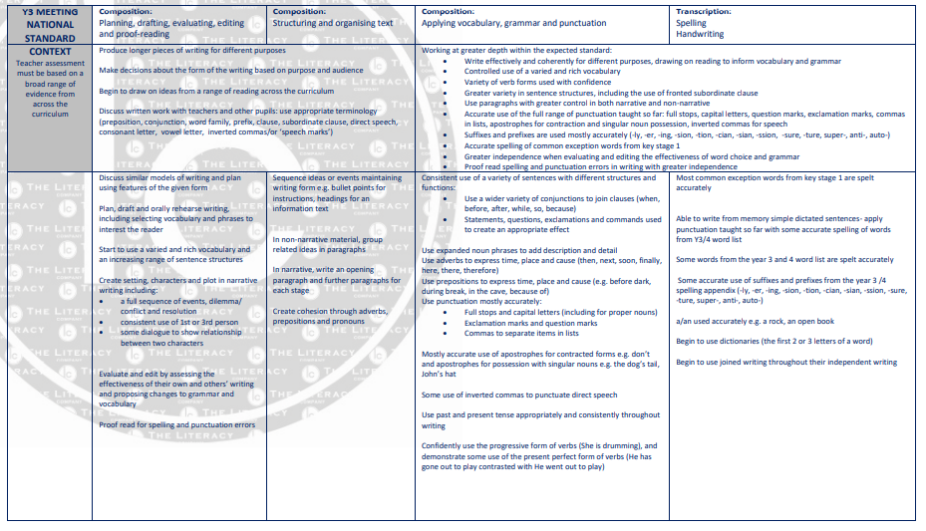

Pathways to Poetry
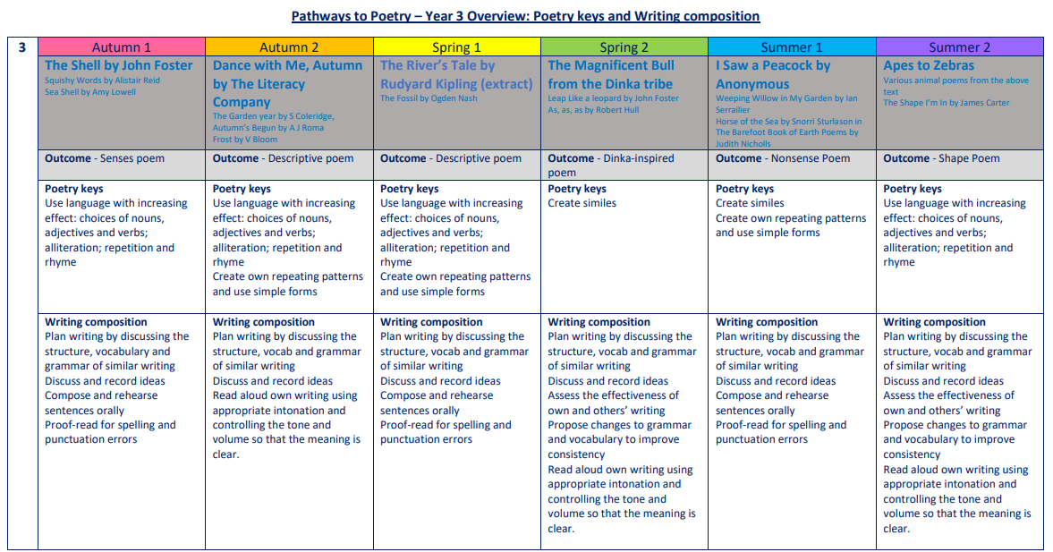

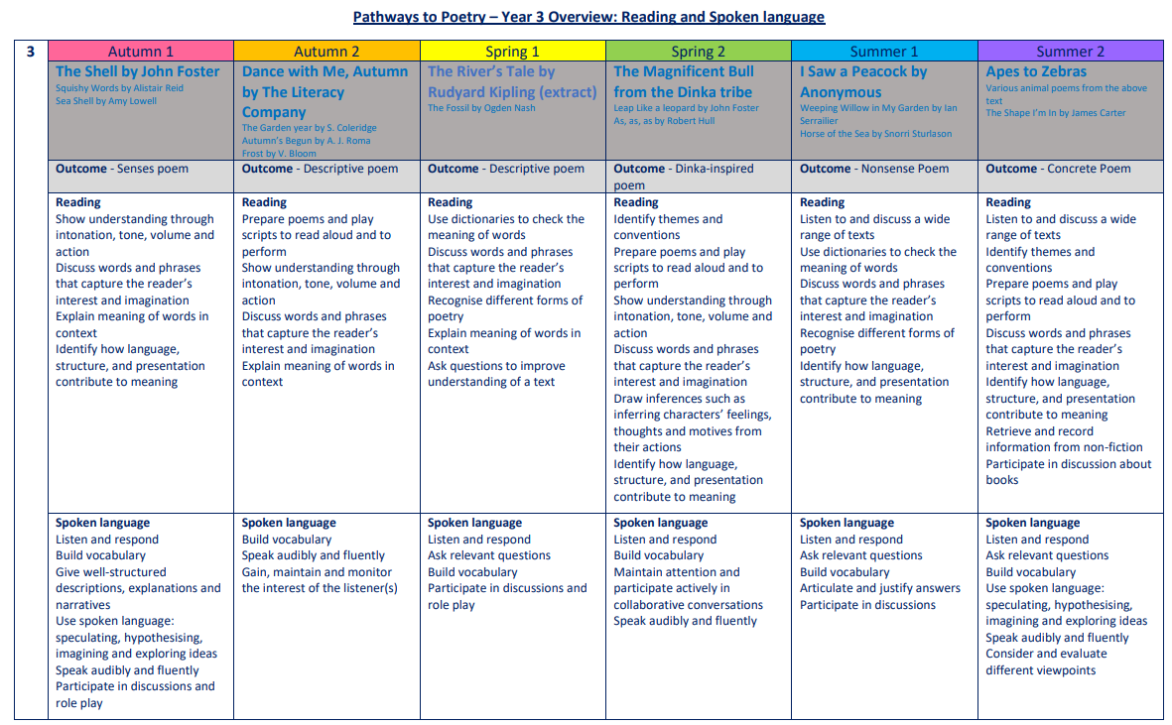

The Five Plagues of the Developing Reader
In his book ‘Reading Reconsidered’, Doug Lemov points out that there are five types of texts that children should have access to in order to successfully navigate reading with confidence. These are complex beyond a lexical level and demand more from the reader than other types of books.
Archaic Language
The vocabulary, usage, syntax and context for cultural reference of texts over 50 or 100 years old are vastly different and typically more complex than texts written today. Students need to be exposed to and develop proficiency with antiquated forms of expression to be able to hope to read James Madison, Frederick Douglass and Edmund Spenser when they get to college.
Non-Linear Time Sequences
In passages written exclusively for students—or more specifically for student assessments— time tends to unfold with consistency. A story is narrated in a given style with a given cadence and that cadence endures and remains consistent, but in the best books, books where every aspect of the narration is nuanced to create an exact image, time moves in fits and start. It doubles back. The only way to master such books is to have read them time and again and to be carefully introduced to them by a thoughtful teacher or parent.
Narratively Complex
Books are sometimes narrated by an unreliable narrator- Scout, for example, who doesn’t understand and misperceives some of what happened to her. Or the narrator in Edgar Allan Poe’s “The Tell-Tale Heart” who is a madman out of touch with reality. Other books have multiple narrators such as Faulkner’s As I Lay Dying. Others have non-human narrators such as the horse that tells the story in Black Beauty. Some books have multiple intertwined and apparently (for a time) unrelated plot lines. These are far harder to read than books with a single plot line and students need to experience these as well.
Figurative/Symbolic Text
Texts which happen on an allegorical or symbolic level. Not reflected in Lexiles; critical forms of text complexity that students must experience.
Resistant Texts
Texts written to deliberately resist easy meaning-making by readers. Perhaps half of the poems ever written fall into this category. You have to assemble meaning around nuances, hints, uncertainties and clues.

Our reading spine acknowledges these barriers, and seeks opportunities to include exposure to these types of texts, as well as those that we believe are a pleasurable experience for our children to engage with.

Year 3: Suggested Weekly Reading Sequence
Session 1 | Session 2 | Session 3 | Session 4 | Session 5
Fluency Reading | Extended Reading | Fluency Reading | Extended Reading | Close Reading

