Term | English Sequences |  | Reading Sequences | Story time texts
Term | Pathways to Write | Poetry Units and Cross-Curricular Writing | Reading Sequences | Story time texts
1 – 7 weeks | Unit: Gorilla by Anthony Browne  Outcome: write a fantasy story (fiction)  (approximately 4 weeks) | Poetry Unit: Family Album  (approximately 1 week)  Cross-curricular writing outcome: History – linked to the topic of ‘Ancient Greece.’  (approximately 1 week) | Whole-class book - The Lion, The Witch and The Wardrobe by C.S. Lewis – archaic text | Revolting Rhymes (poems) by Roald Dahl –  complexity of plot/symbol
2 – 7 weeks | Unit: Greek Myths by Jean Menzies  Outcome: make a mini-book of their own adventure (fiction)  (approximately 4 weeks) | Poetry Unit: The Lost Lost-Property Office by Roger McGough  (approximately 1 week)  Reading and SPAG assessments to be administered (approximately 2 lessons) | RE: Hinduism (Religion in Focus) - links to topic ‘What do Hindus believe God is like?’
2 – 7 weeks |  |  | Geography: Unit information text on the server linked to current/recent topic.  The Brainiac’s Book of the Climate and Weather - links to topic ‘Climate and Weather’
2 – 7 weeks |  |  | History: Unit information text on the server linked to current/recent topic.  The Greeks (Hide-and-Seek History) by Jonny Marx - links to topic ‘Ancient Greece’
2 – 7 weeks |  |  | Science: Unit information text on the server linked to current/recent topic.  Sound (Step Into Science) by Peter Riley - links to topic ‘Sound’
2 – 7 weeks |  |  | Wider curriculum: Choose from wider curriculum KS2 box.
2 – 7 weeks |  |  | Other: The Wolves in the Walls by Neil Gaiman - figurative/symbolic text
3 – 6 weeks | Unit: Our Tower by Joseph Coelho  Outcome: write the adventure as a journal (recount)  (approximately 4 weeks) | Poetry Unit: The Roman Centurion’s Song by Rudyard Kipling  (edited extract)  (approximately 1 week)  Cross-curricular writing outcome: Science – linked to the topic of ‘Electricity’.  (approximately 1 week) | Whole-class book: Charlotte’s Web by E. B. White – archaic text | The Firework Maker’s Daughter by Philip  Pullman – non-linear time sequence
4 – 6 weeks | Unit: Amazing Islands by Sabrina Weiss, Koji’s Island by The Literacy Company  Outcome: write an adventure story from POV of the boy (fiction)  (approximately 4 weeks) | Poetry Unit: Windrush Child by John Agard  (approximately 1 week)  Reading and SPAG assessments to be administered (approximately 2 lessons) | RE: Easter Bible Story about Jesus - links to topic ‘Why do Christians call the day Jesus died Good Friday?’
4 – 6 weeks |  |  | Geography: Unit information text on the server linked to current/recent topic.  Everything: Volcanoes and Earthquakes (National Geographic Kids) – ‘links to topic ‘Tectonic Plates, Volcanoes and Earthquakes’
4 – 6 weeks |  |  | History: Unit information text on the server linked to current/recent topic.  Romans Magnified by David Long – links to topic ‘Ancient Rome and Roman Britain’
4 – 6 weeks |  |  | Science: Unit information text on the server linked to current/recent topic.  Amazing Materials: Solids, liquids and gases by Rob Colson – links to topic ‘Solids, liquids and gases’
4 – 6 weeks |  |  | Wider curriculum: Choose from wider curriculum KS2 box.
4 – 6 weeks |  |  | Other: Escape from Pompeii by Christina Balit – links to geography learning
5 – 5 weeks | Unit: Where the Forest Meets the Sea by Jeannie Baker, Jungle Explorer by The Literacy Company  Outcome: write an information board (non-fiction)  (approximately 4 weeks) | Poetry Unit: Look! by Grace Nichols  (approximately 1 week) | Whole-class book: The Secrets of Vesuvius by Caroline Lawrence – links to Geography learning from Spring 2 | Beowulf by Michael Morpurgo - narratively complex
6 – 7 weeks | Unit: Blue John by Berlie Doherty  Outcome: write a letter (recount)  (approximately 4 weeks) | Poetry Unit: Look Closely! (approximately 1 week)  Cross-curricular writing outcome: RE – linked to the topic ‘What does it mean to be a Sikh in Britian today?’  (approximately 1 week)  Reading and SPAG assessments to be administered (approximately 2 lessons) | RE: We are Sikhs (My Religion and Me) by Philip Blake – links to topic ‘What does it mean to be a Sikh in Britian today?’ | Beowulf by Michael Morpurgo - narratively complex
6 – 7 weeks |  |  | Geography: Unit information text on the server linked to current/recent topic.  Amazing Rivers by Julie Vosburgh Agnone - links to topic ‘Waterways of the UK’ | Beowulf by Michael Morpurgo - narratively complex
6 – 7 weeks |  |  | History: Unit information text on the server linked to current/recent topic.  Viking Voyagers by Jack Tite - links to topic ‘The Anglo-Saxons, the Vikings and the Norman Conquest’ | Beowulf by Michael Morpurgo - narratively complex
6 – 7 weeks |  |  | Science: Unit information text on the server linked to current/recent topic.  Our Planet: The One Place We Call Home by Matt Whyman - links to topic ‘Living things and their habitats’ | Beowulf by Michael Morpurgo - narratively complex
6 – 7 weeks |  |  | Wider curriculum: Choose from wider curriculum KS2 box. | Beowulf by Michael Morpurgo - narratively complex
6 – 7 weeks |  |  | Other: Bill’s New Frock by Anne Fine on Pie Corbett’s reading spine | Beowulf by Michael Morpurgo - narratively complex

Year 4 Mastery Keys
Year 4 | Autumn 1 | Autumn 2 | Spring 1 | Spring 2 | Summer 1 | Summer 2
Year 4 | Word | Word  Use Standard English forms for verb inflections  Recognise the grammatical difference between plural and possessive ‘s’ | Word  Use Standard English forms for verb inflections | Word | Word  Recognise the grammatical difference between plural and possessive ‘s’ | Word
Year 4 | Sentence  Expand noun phrases by the addition of modifying adjectives, nouns and prepositional phrases  Use fronted adverbials | Sentence  Extend the range of sentences with more than one clause by using a wider range of conjunctions including when, if, because, although | Sentence | Sentence  Expand noun phrases by the addition of modifying adjectives, nouns and prepositional phrases | Sentence | Sentence  Extend the range of sentences with more than one clause by using a wider range of conjunctions including when, if, because, although
Year 4 | Text  Organise paragraphs around a theme (to organise and sequence more extended narrative structures)  Choose nouns or pronouns appropriately for clarity and cohesion and to avoid repetition | Text  Build a varied and rich vocabulary | Text  Organise paragraphs around a theme (using fronted adverbials to introduce or connect paragraphs)  Variety of verb forms used correctly and consistently including the progressive and the present perfect forms | Text  Choose nouns or pronouns appropriately for clarity and cohesion and to avoid repetition | Text  Build a varied and rich vocabulary  Organise paragraphs around a theme  Propose changes to grammar and vocabulary to improve consistency, including the accurate use of pronouns in sentences | Text  Organise paragraphs around a theme  Recap: Variety of verb forms used correctly and consistently including the progressive and the present perfect forms
Year 4 | Punctuation  Use commas after fronted adverbials  Recap: Use inverted commas for direct speech | Punctuation  Indicate possession by using the possessive apostrophe with plural nouns | Punctuation  Use and punctuate direct speech (using dialogue to show the relationship between characters) | Punctuation  Use inverted commas and other punctuation to punctuate direct speech  Use commas after fronted adverbials | Punctuation  Indicate possession by using the possessive apostrophe with plural nouns. | Punctuation

Please see the progression documents for text features and grammar on the server. You can also use these documents to ‘track back’ to support your learners. There are also reading & speaking and listening progression documents there too.

Year 4 Assessment Matrix
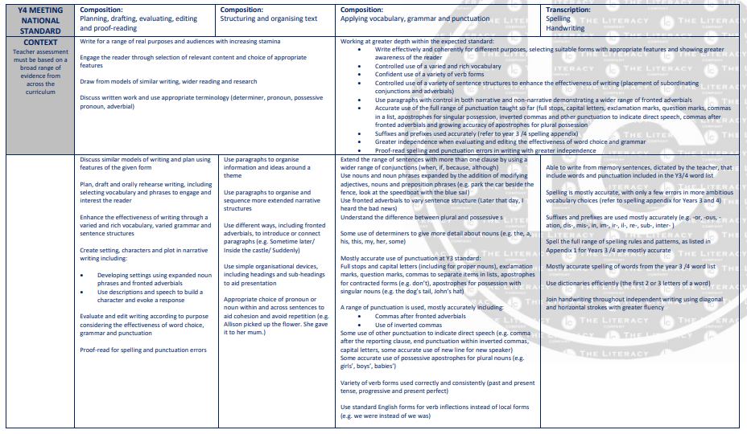

Pathways to Poetry
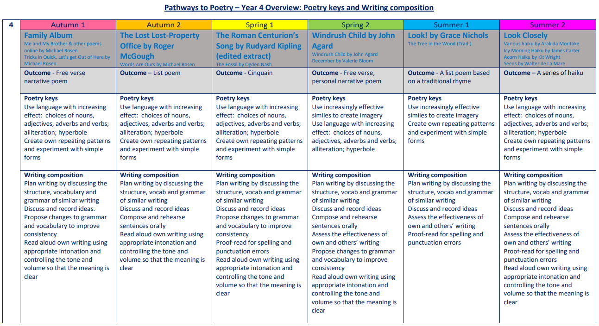

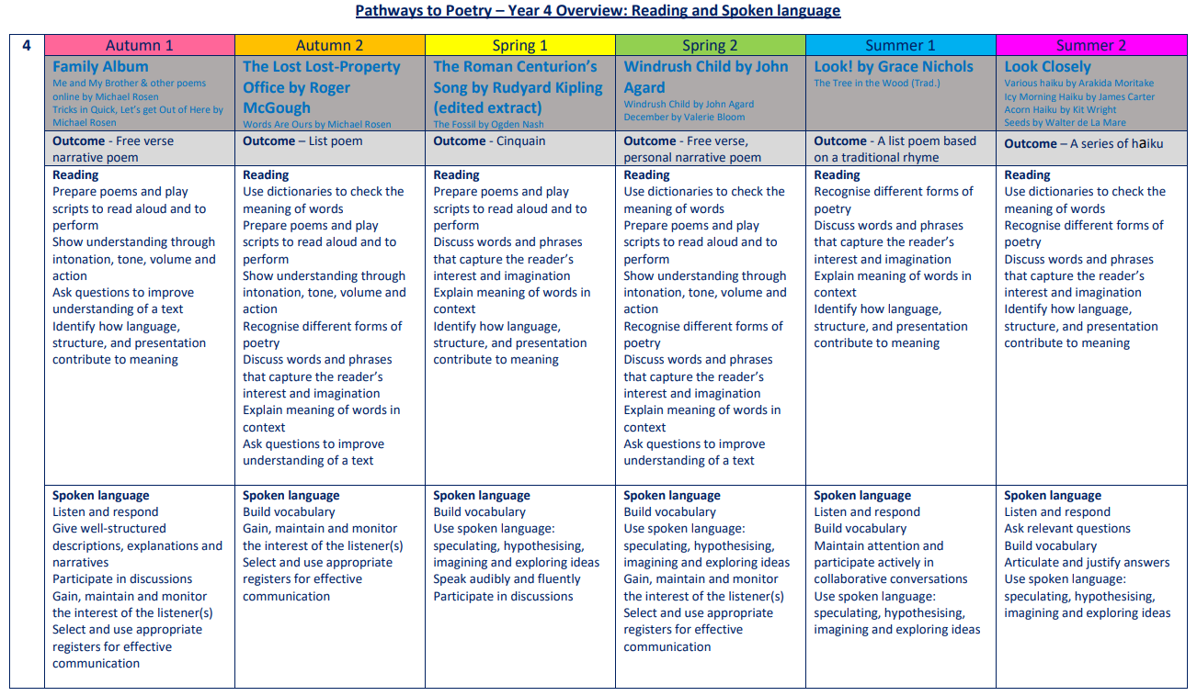

The Five Plagues of the Developing Reader
In his book ‘Reading Reconsidered’, Doug Lemov points out that there are five types of texts that children should have access to in order to successfully navigate reading with confidence. These are complex beyond a lexical level and demand more from the reader than other types of books.
Archaic Language
The vocabulary, usage, syntax and context for cultural reference of texts over 50 or 100 years old are vastly different and typically more complex than texts written today. Students need to be exposed to and develop proficiency with antiquated forms of expression to be able to hope to read James Madison, Frederick Douglass and Edmund Spenser when they get to college.
Non-Linear Time Sequences
In passages written exclusively for students—or more specifically for student assessments— time tends to unfold with consistency. A story is narrated in a given style with a given cadence and that cadence endures and remains consistent, but in the best books, books where every aspect of the narration is nuanced to create an exact image, time moves in fits and start. It doubles back. The only way to master such books is to have read them time and again and to be carefully introduced to them by a thoughtful teacher or parent.
Narratively Complex
Books are sometimes narrated by an unreliable narrator- Scout, for example, who doesn’t understand and misperceives some of what happened to her. Or the narrator in Edgar Allan Poe’s “The Tell-Tale Heart” who is a madman out of touch with reality. Other books have multiple narrators such as Faulkner’s As I Lay Dying. Others have non-human narrators such as the horse that tells the story in Black Beauty. Some books have multiple intertwined and apparently (for a time) unrelated plot lines. These are far harder to read than books with a single plot line and students need to experience these as well.
Figurative/Symbolic Text
Texts which happen on an allegorical or symbolic level. Not reflected in Lexiles; critical forms of text complexity that students must experience.
Resistant Texts
Texts written to deliberately resist easy meaning-making by readers. Perhaps half of the poems ever written fall into this category. You have to assemble meaning around nuances, hints, uncertainties and clues.

Our reading spine acknowledges these barriers, and seeks opportunities to include exposure to these types of texts, as well as those that we believe are a pleasurable experience for our children to engage with.

Year 4: Suggested Weekly Reading Sequence
Session 1 | Session 2 | Session 3 | Session 4 | Session 5
Fluency Reading | Extended Reading | Fluency Reading | Extended Reading | Close Reading

