Term | English Sequences |  | Reading Sequences | Story time texts
Term | Pathways to Write | Poetry Units and Cross-Curricular Writing | Reading Sequences | Story time texts
1 – 7 weeks | Unit: Young, Gifted and Back by Jamia Wilson & Race to the Frozen North: The Matthew Henson Story by Catherine Johnson  Outcome: write a series of diary entries (recount)  (approximately 4 weeks) | Poetry Unit: The Song of Hiawatha by  Henry Wadsworth Longfellow (extract)  (approximately 1 week)  Cross-curricular writing outcome: Science – linked to the topic of ‘Earth and Space.’  (approximately 1 week) | Whole-class book - My Brother’s Ghost by Allan Ahlberg - enjoyable text, reading for pleasure | The Midnight Fox by Betsy Byars – non-linear time sequence
2 – 7 weeks | Unit: The Lost Happy Endings by Carol Ann Duffy  Outcome: write a traditional tale (fiction)  (approximately 4 weeks) | Poetry Unit: The Moon  (approximately 1 week)  Reading and SPAG assessments to be administered (approximately 2 lessons) | RE: The Prophet’s Pond by Zaheer Katri – links to topic ‘What does it mean for Muslims to follow God?’ | The Midnight Fox by Betsy Byars – non-linear time sequence
2 – 7 weeks |  |  | Geography: Unit information text on the server linked to current/recent topic.  Mountains (World of Wonder) by Charlotte Guillain – links to autumn 2 topic ‘what mountain shall we climb?’ | The Midnight Fox by Betsy Byars – non-linear time sequence
2 – 7 weeks |  |  | History: Unit information text on the server linked to current/recent topic.  Early Islamic Civilisation by Izzi Howell – links to autumn 1 history topic | The Midnight Fox by Betsy Byars – non-linear time sequence
2 – 7 weeks |  |  | Science: Unit information text on the server linked to current/recent topic.  Planetarium (Junior Edition) – links to Earth and Space science topic in autumn 1 | The Midnight Fox by Betsy Byars – non-linear time sequence
2 – 7 weeks |  |  | Wider curriculum: Choose from wider curriculum KS2 box. | The Midnight Fox by Betsy Byars – non-linear time sequence
2 – 7 weeks |  |  | Other: Sky in the Pie (poems) by Roger McGough – resistant text  The Pobble Who Has No Toes (poem) by Edward Lear – resistant text | The Midnight Fox by Betsy Byars – non-linear time sequence
3 – 6 weeks | Unit: Arthur and the Golden Rope by Joe Todd-Stanton  Outcome: write a myth (fiction)  (approximately 4 weeks) | Poetry Unit: Viking Kennings & Spells  (approximately 1 week)  Cross-curricular writing outcome: RE – linked to the topic of ‘Creation and Science: Conflicting or Complementary’  (approximately 1 week) | Whole-class book: Black Beauty by Anna Sewell – archaic text | The Invention of Hugo Cabret by Brian Selznick- reading for pleasure, previous year groups have loved it!
4 – 6 weeks | Unit: The Darkest Dark by Chris Hadfield  Outcome: write a biography (recount)  (approximately 4 weeks) | Poetry Unit: Finding Magic by Eric Finney  (approximately 1 week)  Reading and SPAG assessments to be administered (approximately 2 lessons) | RE: The Lion Storyteller Bible by Bob Hartman – links to spring 2 RE topic ‘What do Christians believe Jesus did to save people?’
4 – 6 weeks |  |  | Geography: Unit information text on the server linked to current/recent topic.  Earth Heroes: 20 Inspiring Stories of People Saving Our World – links to spring 2 topic ‘Are we damaging our world?’
4 – 6 weeks |  |  | History: Unit information text on the server linked to current/recent topic.  Benin by Izzi Howell – links to spring 1 history topic ‘The Kingdom of Benin’
4 – 6 weeks |  |  | Science: Unit information text on the server linked to current/recent topic.  Why do we wear clothes? By Helen Hancocks – links to spring topic ‘materials and their properties’
4 – 6 weeks |  |  | Wider curriculum: Choose from wider curriculum KS2 box.
4 – 6 weeks |  |  | Other: Wonder by R.J. Palacio – complexity of the narrator
5 – 5 weeks | Unit: The Paperbag Prince by Colin Thompson  Outcome: write a hybrid leaflet (persuasion/ information)  (approximately 4 weeks) | Poetry Unit: The Sun in Me by Moira Andrew  (approximately 1 week) | Whole-class book: Treasure Island (children’s version) – archaic text | Wolf Brother by Michelle Paver– on Pie Corbett’s reading spine
6 – 7 weeks | Unit: Radiant Child by Javaka Steptoe & Life Doesn’t Frighten Me by Maya Angelou  Outcome: write an information text (non-fiction)  (approximately 4 weeks) | Poetry Unit: Animals of Africa (approximately 1 week)  Cross-curricular writing outcome: Geography – linked to the topic ‘How is our country changing?’ (Changes to UK and Peterborough)  (approximately 1 week)  Reading and SPAG assessments to be administered (approximately 2 lessons) | RE: World Religions by Brian Doyle – compliments RE learning from across the year
6 – 7 weeks |  |  | Geography: Unit information text on the server linked to current/recent topic.  The Big Book of the UK – links to summer 2 topic ‘How is our country changing?’ (Changes to UK and Peterborough)
6 – 7 weeks |  |  | History: Unit information text on the server linked to current/recent topic.  Tudor (DK Eyewitness) – links to summer 1 topic ‘The Tudors’
6 – 7 weeks |  |  | Science: Unit information text on the server linked to current/recent topic.  Living Habitats by Jon Richards – links to summer 2 topic ‘living things and their habitats’
6 – 7 weeks |  |  | Wider curriculum: Choose from wider curriculum KS2 box.
6 – 7 weeks |  |  | Other: FArTHER by Grahame Baker-Smith – on Pie Corbett’s reading spine

Year 5 Mastery Keys
Year 5 | Autumn 1 | Autumn 2 | Spring 1 | Spring 2 | Summer 1 | Summer 2
Year 5 | Word | Word | Word | Word | Word | Word
Year 5 | Sentence | Sentence  Use expanded noun phrases to convey complicated information concisely | Sentence  Use expanded noun phrases to convey complicated information concisely  Use relative clauses beginning with who, which, where, when, whose, that or an omitted relative pronoun | Sentence  Extend the range of sentences with more than one clause by using a wider range of conjunctions | Sentence  Use modal verbs to indicate degrees of possibility | Sentence  Use relative clauses beginning with who, which, where, when, whose, that or an omitted relative pronoun  Use adverbs to indicate degrees of possibility
Year 5 | Text  Identify the audience for and purpose of writing  Organise paragraphs around a theme with a focus on more complex narrative structures | Text  Describe settings, characters and atmosphere  Integrate dialogue to convey character and advance the action | Text  Link ideas across paragraphs using adverbials | Text  Link ideas across paragraphs using adverbials and tense choices  Recap: Variety of verb forms used correctly and consistently | Text  Use devices to build cohesion within a paragraph  Choose the appropriate register  Enhance meaning through selecting appropriate grammar and vocabulary | Text  Use a wider range of devices to build cohesion across paragraphs  Link ideas using tense choices
Year 5 | Punctuation  Use commas after fronted adverbials (Y4)  Use commas to clarify meaning or avoid ambiguity in writing | Punctuation  Use of inverted commas and other punctuation to punctuate direct speech (Y4) | Punctuation  Use commas to clarify meaning or avoid ambiguity in writing | Punctuation  Use commas to clarify meaning or avoid ambiguity in writing  Use brackets, dashes or commas to indicate parenthesis | Punctuation  Use brackets, dashes or commas to indicate parenthesis | Punctuation

Please see the progression documents for text features and grammar on the server. You can also use these documents to ‘track back’ to support your learners. There are also reading & speaking and listening progression documents there too.
Year 5 Assessment Matrix
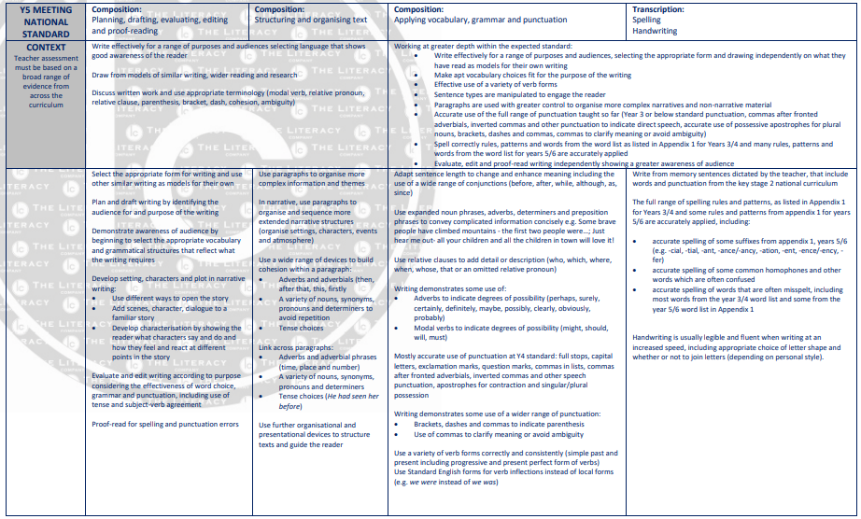

Pathways to Poetry
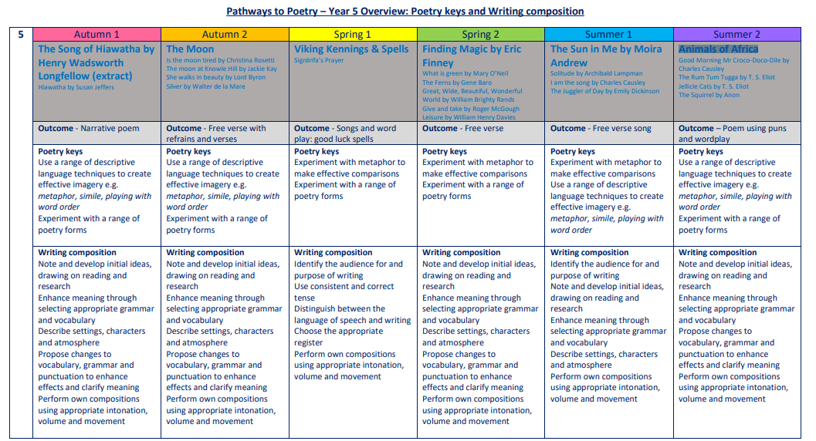

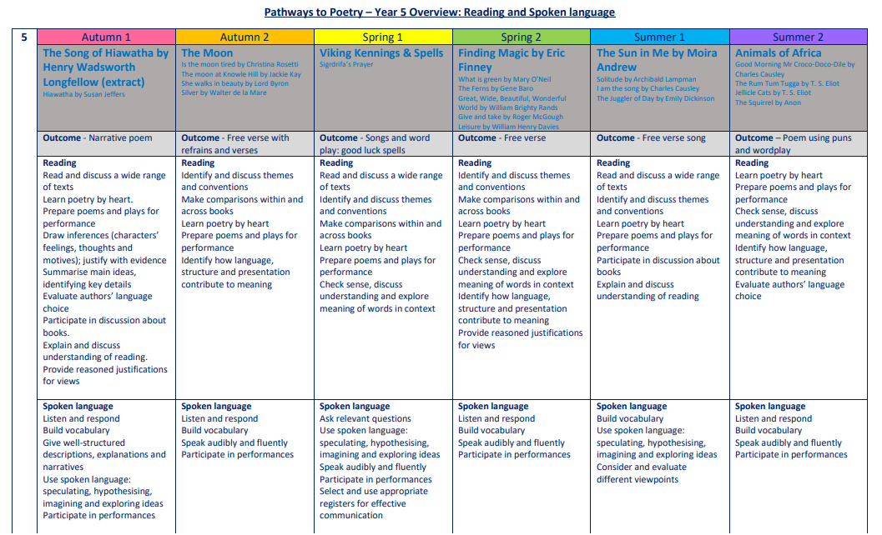

The Five Plagues of the Developing Reader
In his book ‘Reading Reconsidered’, Doug Lemov points out that there are five types of texts that children should have access to in order to successfully navigate reading with confidence. These are complex beyond a lexical level and demand more from the reader than other types of books.
Archaic Language
The vocabulary, usage, syntax and context for cultural reference of texts over 50 or 100 years old are vastly different and typically more complex than texts written today. Students need to be exposed to and develop proficiency with antiquated forms of expression to be able to hope to read James Madison, Frederick Douglass and Edmund Spenser when they get to college.
Non-Linear Time Sequences
In passages written exclusively for students—or more specifically for student assessments— time tends to unfold with consistency. A story is narrated in a given style with a given cadence and that cadence endures and remains consistent, but in the best books, books where every aspect of the narration is nuanced to create an exact image, time moves in fits and start. It doubles back. The only way to master such books is to have read them time and again and to be carefully introduced to them by a thoughtful teacher or parent.
Narratively Complex
Books are sometimes narrated by an unreliable narrator- Scout, for example, who doesn’t understand and misperceives some of what happened to her. Or the narrator in Edgar Allan Poe’s “The Tell-Tale Heart” who is a madman out of touch with reality. Other books have multiple narrators such as Faulkner’s As I Lay Dying. Others have non-human narrators such as the horse that tells the story in Black Beauty. Some books have multiple intertwined and apparently (for a time) unrelated plot lines. These are far harder to read than books with a single plot line and students need to experience these as well.
Figurative/Symbolic Text
Texts which happen on an allegorical or symbolic level. Not reflected in Lexiles; critical forms of text complexity that students must experience.
Resistant Texts
Texts written to deliberately resist easy meaning-making by readers. Perhaps half of the poems ever written fall into this category. You have to assemble meaning around nuances, hints, uncertainties and clues.
Our reading spine acknowledges these barriers, and seeks opportunities to include exposure to these types of texts, as well as those that we believe are a pleasurable experience for our children to engage with.
Year 5: Suggested Weekly Reading Sequence
Session 1 | Session 2 | Session 3 | Session 4 | Session 5
Fluency Reading | Extended Reading | Close Reading | Extended Reading | Close Reading

