Term | English Sequences |  | Reading Sequences | Story time texts
Term | Pathways to Write | Poetry Units and Cross-Curricular Writing | Reading Sequences | Story time texts
1 – 7 weeks | Unit: Star of Fear, Star of Hope by Jo Hoestlandt, Erika’s Story by Ruth Vander Zee  Outcome: write a story with a flashback (fiction)  (approximately 4 weeks) | Poetry Unit: Blitz by Mary Désirée Anderson  (approximately 1 week)  Cross-curricular writing outcome: Science – linked to the topic of ‘Light’  (approximately 1 week) | Whole-class book - The Nowhere Emporium by Ross MacKenzie - enjoyable text, reading for pleasure | Skellig by David Almond – complexity of plot/symbol
2 – 7 weeks | Unit: Can We Save the Tiger? By Martin Jenkins  Outcome: hybrid text (information/explanation)  (approximately 4 weeks) | Poetry Unit: A Tiger in the Zoo by Leslie Norris  (approximately 1 week)  Reading and SPAG assessments to be administered (approximately 2 lessons) | RE: The Diary of Anne Frank (The Graphic Adaptation) - context & history, links to RE unit on Judaism | Skellig by David Almond – complexity of plot/symbol
2 – 7 weeks |  |  | Geography: Unit information text on the server linked to current/recent topic.  Shackleton’s Journey by William Grill – links to North and South Pole topic | Skellig by David Almond – complexity of plot/symbol
2 – 7 weeks |  |  | History: Unit information text on the server linked to current/recent topic.  Victorians (Eyewitness) by Ann Kramer – great non-fiction text linked to Victorian topic | Skellig by David Almond – complexity of plot/symbol
2 – 7 weeks |  |  | Science: Unit information text on the server linked to current/recent topic.  On a Beam of Light: A Story of Albert Enstein by Jennifer Berne - links to autumn 1 science learning | Skellig by David Almond – complexity of plot/symbol
2 – 7 weeks |  |  | Wider curriculum: Choose from wider curriculum KS2 box. | Skellig by David Almond – complexity of plot/symbol
2 – 7 weeks |  |  | Other: A Christmas Carol by Charles Dickens – archaic text  The Arrival by Shaun Tan – resistant text | Skellig by David Almond – complexity of plot/symbol
3 – 6 weeks | Unit: The Selfish Giant by Oscar Wilde & Ritva Voutila  Outcome: write a classic narrative (fiction)  (approximately 4 weeks) | Poetry Unit: Guarding Secrets by The Literacy Company  (approximately 1 week)  Cross-curricular writing outcome: History – linked to the topic of ‘World War 2’  (approximately 1 week) | RE: Martin Luther King Jr. – Little People, Big Dreams – BAME  This is your time by Ruby Bridges - BAME | Goodnight Mister Tom - set in war, draws on historical knowledge from Spring term
3 – 6 weeks |  |  | Geography: Unit information text on the server linked to current/recent topic.  The National Archives: The Buildings That Made London – links to study of the UK
3 – 6 weeks |  |  | History: Unit information text on the server linked to current/recent topic.  Tales of World War II: Amazing True Stories from the War that Shook the World – links to World War 2 topic
3 – 6 weeks |  |  | Science: Unit information text on the server linked to current/recent topic.  Living Habitats (The Big Picture) by Jon Richards – links to living things and their habitats topic
3 – 6 weeks |  |  | Wider curriculum: Choose from wider curriculum KS2 box
3 – 6 weeks |  |  | Other: War Horse by Michael Morpurgo – complexity of the narrator  The Island by Armin Greder – symbolic text
4 – 6 weeks | Unit: Island by Jason Chin, Jemmy Button by Alix Barzelay  Outcome: write a journalistic report (recount)  (approximately 4 weeks) | Poetry Unit: The Sea by James Reeves  (approximately 1 week)  Reading and SPAG assessments to be administered (approximately 2 lessons) | RE: The Kids Book of World Religions – overview of different religions to consolidate learning across KS2
4 – 6 weeks |  |  | Geography: Unit information text on the server linked to current/recent topic.  France by Clive Gifford – links to study of France
4 – 6 weeks |  |  | History: Unit information text on the server linked to current/recent topic.  Rosa Parks: Little People, Big Dreams – links to civil rights
4 – 6 weeks |  |  | Science: Unit information text on the server linked to current/recent topic.  Life: The First Four Billion Years – links to evolution and adaptation topic
4 – 6 weeks |  |  | Wider curriculum: Choose from wider curriculum KS2 box
4 – 6 weeks |  |  | Other: In Flanders Fields (poem) by John McCrae - complexity of plot/symbol  The Tyger by William Blake (poem) – resistant text  The Highwayman (poem) by Alfred Noyes – archaic text
5 – 5 weeks | Unit: Manfish by Jennifer Berne, Great Adventurers by Alistair Humphreys  Outcome: write a biography (fiction)  (approximately 4 weeks) | Poetry Unit: For Forest by Grace Nichols  (approximately 1 week) | Whole-class book: The Final Year by Matt Goodfellow – preparing for transition to secondary school | Ella on the Outside by Cath Howe – transition to secondary
6 – 7 weeks | Unit: Sky Chasers by Emma Carroll  Outcome: write an adventure story (fiction)  (approximately 4 weeks) | Poetry Unit: Sonnet Written at the Close of Spring by Charlotte Smith (approximately 1 week)  Cross-curricular writing outcome: RE – linked to the topic ‘How do religions help people through good times and bad?’  (approximately 1 week)  Reading and SPAG assessments to be administered (approximately 2 lessons) | Whole-class book: Holes – nonlinear time sequence | Ella on the Outside by Cath Howe – transition to secondary

Year 6 Mastery Keys
Year 6 | Autumn 1 | Autumn 2 | Spring 1 | Spring 2 | Summer 1 | Summer 2
Year 6 | Word | Word | Word | Word | Word | Word
Year 6 | Sentence  Use expanded noun phrases to convey complicated information concisely  Use passive verbs | Sentence  Use modal verbs or adverbs to indicate degrees of possibility (Y5) | Sentence  Recognise structures for formal speech and writing, including subjunctive forms  Use passive verbs | Sentence  Use passive verbs | Sentence  Use relative clauses beginning with who, which, where, when, whose, that or an omitted relative pronoun (Y5) | Sentence  Recognise vocabulary and structures for formal speech and writing, including subjunctive forms
Year 6 | Text  Link ideas across paragraphs using a wider range of cohesive devices  Integrate dialogue to convey character and advance the action | Text  Enhance meaning through selecting appropriate grammar and vocabulary | Text  Distinguish between the language of speech and writing  Integrate dialogue to convey character and advance the action | Text  Use a wider range of devices to build cohesion  Use organisational and presentational devices to structure text  Variety of verb forms used correctly and consistently (progressive present perfect forms) | Text  Use a wider range of devices to build cohesion | Text  Identify the audience for and purpose of writing  Choose the appropriate register
Year 6 | Punctuation  Punctuate bullet points consistently | Punctuation  Use brackets, dashes or commas to indicate parenthesis (Y5) | Punctuation  Use semi-colons to mark boundaries between independent clauses | Punctuation  Use colons or dashes to mark boundaries between independent clauses | Punctuation  Use a colon to introduce a list and use of semi-colons within lists  Use hyphens to avoid ambiguity | Punctuation  Use semi-colons, colons or dashes to mark boundaries between independent clauses
*Objectives in italics are writing composition objectives

Please see the progression documents for text features and grammar on the server. You can also use these documents to ‘track back’ to support your learners. There are also reading & speaking and listening progression documents there too.
Year 6 Assessment Matrix
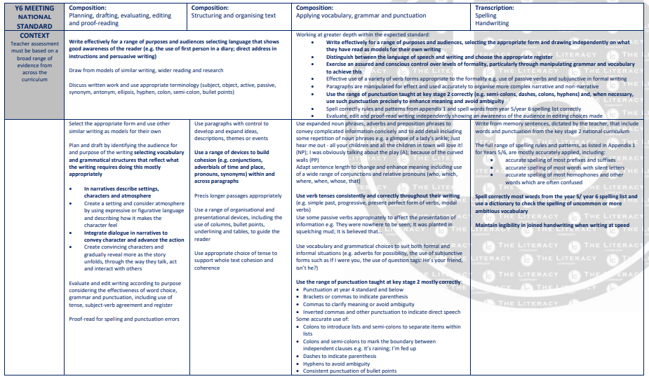

Pathways to Poetry
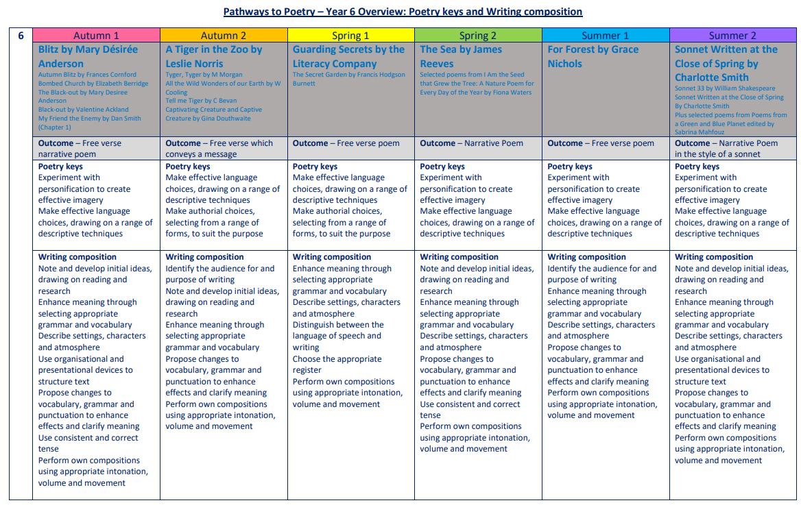

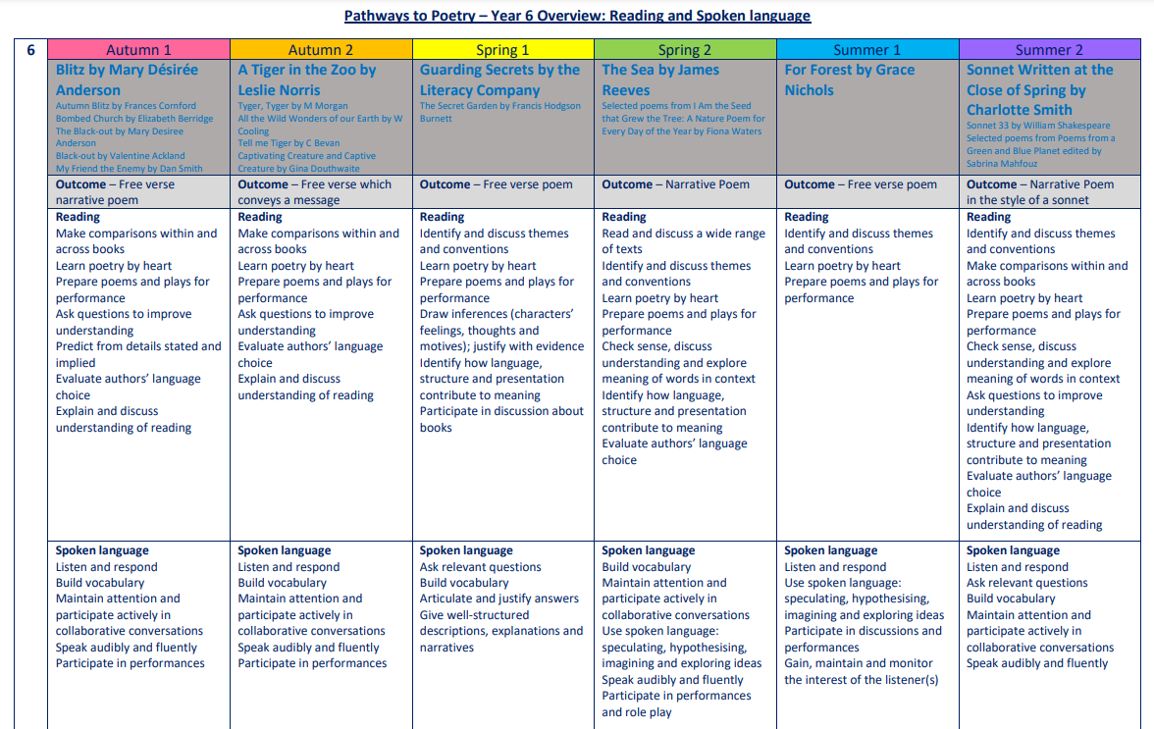

The Five Plagues of the Developing Reader
In his book ‘Reading Reconsidered’, Doug Lemov points out that there are five types of texts that children should have access to in order to successfully navigate reading with confidence. These are complex beyond a lexical level and demand more from the reader than other types of books.
Archaic Language
The vocabulary, usage, syntax and context for cultural reference of texts over 50 or 100 years old are vastly different and typically more complex than texts written today. Students need to be exposed to and develop proficiency with antiquated forms of expression to be able to hope to read James Madison, Frederick Douglass and Edmund Spenser when they get to college.
Non-Linear Time Sequences
In passages written exclusively for students—or more specifically for student assessments— time tends to unfold with consistency. A story is narrated in a given style with a given cadence and that cadence endures and remains consistent, but in the best books, books where every aspect of the narration is nuanced to create an exact image, time moves in fits and start. It doubles back. The only way to master such books is to have read them time and again and to be carefully introduced to them by a thoughtful teacher or parent.
Narratively Complex
Books are sometimes narrated by an unreliable narrator- Scout, for example, who doesn’t understand and misperceives some of what happened to her. Or the narrator in Edgar Allan Poe’s “The Tell-Tale Heart” who is a madman out of touch with reality. Other books have multiple narrators such as Faulkner’s As I Lay Dying. Others have non-human narrators such as the horse that tells the story in Black Beauty. Some books have multiple intertwined and apparently (for a time) unrelated plot lines. These are far harder to read than books with a single plot line and students need to experience these as well.
Figurative/Symbolic Text
Texts which happen on an allegorical or symbolic level. Not reflected in Lexiles; critical forms of text complexity that students must experience.
Resistant Texts
Texts written to deliberately resist easy meaning-making by readers. Perhaps half of the poems ever written fall into this category. You have to assemble meaning around nuances, hints, uncertainties and clues.

Our reading spine acknowledges these barriers, and seeks opportunities to include exposure to these types of texts, as well as those that we believe are a pleasurable experience for our children to engage with.
Year 6: Suggested* Weekly Reading Sequence
Session 1 | Session 2 | Session 3 | Session 4 | Session 5
Fluency Reading | Extended Reading | Close Reading | Extended Reading | Close Reading

