

Design and Technology at Eye CE Primary School

Our Aim
At Eye CE Primary School, the intent for Design and Technology (D&T) is to provide a rigorous, innovative, and inspiring curriculum that equips our pupils with the knowledge, skills, and understanding to engage confidently in an ever-changing world. Our D&T curriculum aims to nurture creativity, problem-solving abilities, technical understanding, and practical skills.
We aim to ensure that pupils develop a deep appreciation for design processes, sustainability, and the impact of technology on society. We aim to foster a sense of curiosity and resilience in our pupils, encouraging them to explore, experiment, and evaluate their ideas while building the confidence to express their creativity through practical means.

Our school definition of Design and Technology
DT is designing and making something for somebody for some purpose.

How we do this
The implementation of our D&T curriculum at Eye CE Primary School focuses on a well-structured progression of skills and knowledge from Foundation Stage through to Key Stage 2. We provide opportunities for pupils to develop their design and making skills using a variety of materials and tools, with a clear emphasis on exploration and experimentation.
Currently, we teach DT and Art on a 6-weekly rotation. We use Kapow and The DT Association to supplement our DT curriculum.
Our D&T lessons are carefully planned to engage pupils in a range of stimulating design challenges that promote teamwork, critical thinking, and problem-solving. We incorporate real-life contexts and cross-curricular links to enhance pupils' understanding of the wider implications of design decisions and technological developments.
Through hands-on experiences, pupils learn to apply their knowledge of structures, mechanisms, electrical systems, and materials to create purposeful and innovative products. We also place a strong emphasis on teaching pupils about sustainability, encouraging them to consider the environmental impact of their designs and the importance of ethical and responsible practices.
Our staff receive responsive CPD to develop their subject knowledge and pedagogy, so that all DT instruction is of a high quality.
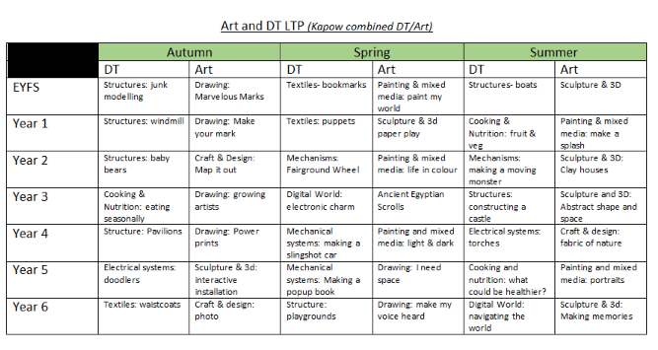

Outcomes
The impact of our D&T provision at Eye CE Primary School is evident in the high levels of engagement, creativity, and achievement demonstrated by our pupils. Through regular monitoring, assessment, and feedback, we ensure that pupils make consistent progress in their design skills and understanding of technological principles.
Pupils at our school develop a strong sense of pride and accomplishment in their D&T projects, showcasing their ingenuity and problem-solving abilities through a wide range of products and prototypes. They demonstrate a deep understanding of the design process, from initial concept to evaluation, and they are able to articulate their decision-making and design choices confidently.
Our D&T curriculum has a positive impact on pupils' wider learning, fostering transferable skills such as resilience, collaboration, and resourcefulness that are valuable across all areas of the curriculum and in later life. Pupils leave Eye CE Primary School with a passion for creativity, a solid foundation in design and technology, and the confidence to tackle challenges with ingenuity and flair.

Alignment with our vision and values / opportunities for developing spirituality
The subject of Design and Technology (DT) plays a crucial role in aligning with our school's vision and values, particularly in the context of "living life in all its fullness," as inspired by John 10:10. DT encourages students to explore their creativity, problem-solving skills, and innovation, allowing them to experience the fullness of their abilities and potential. Through hands-on projects, students can see the tangible results of their efforts, which fosters a sense of accomplishment and joy—key aspects of living a full and meaningful life.
Moreover, DT provides rich opportunities for students to develop spiritually. By engaging in collaborative work, they learn the value of teamwork, empathy, and respect for others' ideas, which are integral to spiritual growth. DT projects often involve reflecting on the needs of others, encouraging students to think beyond themselves and develop a sense of purpose and service. This aligns with our school's vision of nurturing compassionate, reflective individuals who contribute positively to society.
In essence, DT is not just about technical skills; it is about holistic development. It allows students to engage deeply with their learning, fostering a sense of wonder and curiosity about the world, which is at the heart of spiritual growth. Through this subject, pupils can truly experience "life in all its fullness," growing intellectually, emotionally, and spiritually.

July 2024

