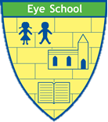

Art and Design at Eye CE Primary School

Our Aim
At Eye CE Primary School, we aim for our Art and Design curriculum to inspire creativity, develop cultural awareness, and instil a lifelong appreciation for the arts in our pupils. We believe that exposure to high-quality art education fosters critical thinking, problem-solving skills, and emotional intelligence. Our curriculum aims to provide a well-rounded education that celebrates diversity, encourages imaginative thinking, and nurtures individual expression. We are committed to ensuring that our children have the opportunity to explore their artistic talents, flourish and achieve.

Our school definition of Art and Design
Art and Design focusses on developing creativity, imagination, and visual expression. It introduces us to various artistic techniques, materials, and mediums, encouraging us to explore and express our ideas through drawing, painting, sculpture, and other forms of visual art. Through Art and Design, we foster an appreciation of art by learning about the work of different artists and cultures, helping us to understand and comment on art while building confidence in our artistic abilities.

How we do this
Our Art and Design curriculum is carefully structured to deliver high-quality teaching and learning experiences that engage, challenge, and inspire our pupils. We have a progressive curriculum that builds upon prior knowledge and skills, incorporating a range of artistic techniques, styles, and mediums.
Through a combination of approaches, pupils at Eye CE Primary School are encouraged to explore their creativity, develop their technical skills, and showcase their work through various platforms within the school and the wider community. We aim to develop a rich cultural heritage by inviting local artists to enrich our pupils' learning experiences and broaden their understanding of the artistic world.
Currently, we teach Art & Design on a 6-weekly rotation alongside DT. We use Kapow to supplement our Art & Design curriculum. Our staff receive responsive CPD to develop their subject knowledge and pedagogy, so that all Art & Design instruction is of a high quality.

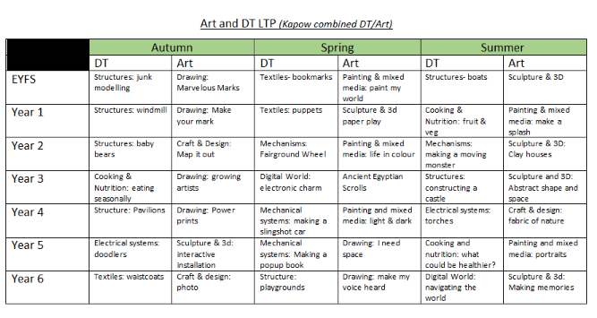
Our wonderful Forest School provides additional opportunities for art, where pupils engage in outdoor art activities, connecting with nature and using natural materials to create artworks. These sessions provide a unique environment for creativity and exploration, allowing pupils to develop their artistic skills in a natural setting.

Outcomes
The impact of our Art and Design curriculum at Eye CE Primary School is evident in the artistic achievements, confidence, and personal growth of our pupils. By providing a nurturing environment that values creativity and self-expression, we have witnessed a noticeable improvement in pupils' artistic skills, cultural awareness, and ability to communicate ideas visually. Pupils develop a sense of ownership and pride in their work, leading to increased motivation, engagement, and a positive attitude towards learning.
Our commitment to promoting diversity and inclusion in the arts has helped to create a welcoming and inclusive school environment where every child feels empowered to express themselves creatively. The impact of our curriculum is not limited to academic achievements but extends to the holistic development of each child, fostering a lifelong love for the arts and a sense of cultural appreciation.

Alignment with our vision and values / opportunities for developing spirituality
Art & Design play a pivotal role in fulfilling our school vision by nurturing creativity, self-expression, and spiritual growth amongst pupils. This subject provides a platform for students to explore their emotions, understand the world around them, and appreciate beauty in its various forms, fostering a deep sense of wonder and reverence for life.

Living Life in All Its Fullness through Art & Design
Art & Design allow students to experience the fullness of life by encouraging them to think creatively and express their thoughts, ideas, and emotions. Through hands-on activities and creative projects, pupils engage in problem-solving and critical thinking, which are essential skills for a fulfilling life. By exploring different cultures, historical contexts, and artistic techniques, students gain a broader understanding of the world, enriching their lives with diverse perspectives and experiences.

Opportunities for Spiritual Development
Art & Design provide numerous opportunities for pupils to develop their spirituality. The creative process often involves self-reflection, contemplation, and a deep connection with one’s inner self. This introspective aspect of art encourages pupils to explore their beliefs, values, and emotions, which are integral to spiritual growth. Moreover, the appreciation of beauty in art can lead to a sense of awe and wonder, fostering a deeper connection with the divine and the world around them.

Alignment with School Values
The values embedded in our school’s vision—such as respect and community—are closely aligned with the principles of Art & Design. Through collaborative projects, students learn the importance of working together, respecting diverse viewpoints, and appreciating the contributions of others. Art also cultivates empathy by allowing students to step into the shoes of others and see the world from different perspectives, thus fostering a sense of community and shared humanity.

In summary, Art & Design are not only essential for academic development but also for nurturing the whole child, allowing them to live life in all its fullness. Through this subject, our students develop the creativity, critical thinking, and spiritual awareness needed to navigate and appreciate the complexities of life, making them well-rounded individuals aligned with the vision and values of our school.

July 2024

