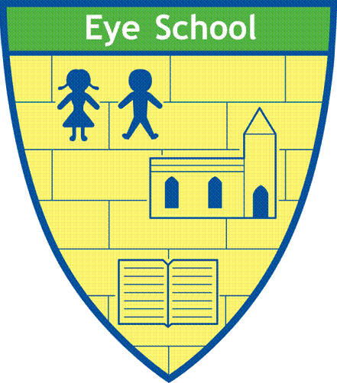

Eye C of E Primary School
Learning and Growing Together
“I came to give life, life in all its fullness.” John 10:10

Forest School Policy

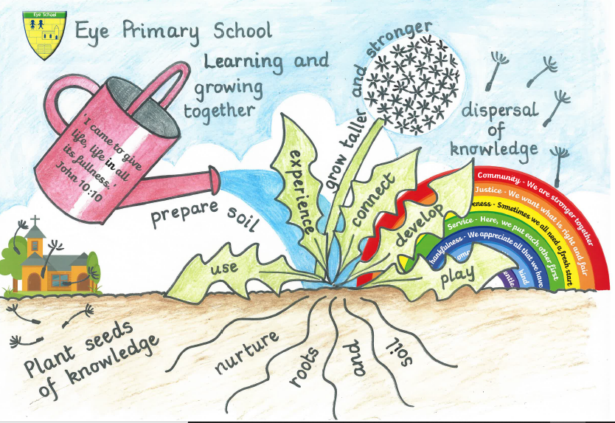

DATE: October 2020
Eye Primary School Forest School Policy

Introduction
Our vision at Eye C of E Primary School is for all children to have full lives the full, in line with Jesus’ teaching
“I have come that they may have life, and have it to the full.” John 10:10
To help fulfil our vision, we have introduced Forest School provision at our school in order to help educate the whole child.

This policy has been specifically written so that all parents, staff, volunteers and governors at Eye C of E Primary School have a shared understanding of the Forest School ethos and its implementation at our school.

The contents of this policy should be read alongside the following policies:

Health and Safety Policy
Behaviour Policy
Safeguarding Policy
Special Educational Needs Policy

Within this policy, the term ‘Forest School Leader’ refers to a member of staff, who holds a fully recognised Level 3 Forest School Practitioners qualification.

Aims
The aim of this policy is to provide an insight into the ethos of Forest School as operated at Eye Primary. Forest School builds on a child’s innate motivation and positive attitude to learning, offering them the opportunities to take risk, make choices and initiate learning for themselves.

Our Forest School learning environment provides opportunities for children to:

Develop self-esteem
Develop self-confidence
Form positive relationships with others
Develop a growing awareness of their emotional needs and the needs of others
Learn to cooperate and work with their peers and adults
Develop strategies in order to take risks within the boundaries of safety.
Learn specific skills which link into the curriculum
Develop knowledge and appreciation of the natural world and a forest environment

Eye Primary’s Forest School is about exploring and experiencing the natural world through practical activities. The children go out in all weathers, all year round, exploring and learning from the seasons and changes in the environment. Appropriate clothing will be worn. During high winds or lightening it will be considered unsafe to go into the woods.

The children’s interests along with the varied natural resources in our woodland are used to stimulate creative thinking, problem solving and skill development, all under the premise of ‘play.’

Environmental Considerations and Conservation
One of the principles of our Forest School is to promote environmental awareness and encourage sustainability. The children are taught respect and responsibility for the world around them. Both children and adults are encouraged to respect their environment and to be aware of conservation issues of the woodland around them.

We aim to promote respect for wildlife and our woodland environment. This will be achieved partly through detailed long-term, medium-term and lesson planning. Careful reference will be made to our woodland management plan and ecological impact assessment. If appropriate, reclaimed, recycled and sustainable resources will be used to maintain and develop our Forest School Site.

Health and Safety Considerations
In the first instance please refer to Eye Primary’s Health and Safety Policy.
The health and safety of the adults and children is paramount at all times throughout any Forest School activity and session. Safe practice is reinforced through regular reminders. The Forest School programme provides children with opportunities to develop independence and to take responsibility for their own learning. Whilst being independent in their learning, they will develop early risk assessment strategies and understand that their actions have consequences.

The Forest School Leaders will carry out risk assessments at the beginning of each term which will take account of seasonal changes. In addition, a risk assessment will be undertaken before each session by the Forest School Leader, who will assess the area for any dangers.

The Forest School site at Eye Primary School is situated towards the back of the school site to the left hand side of the school building.

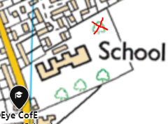
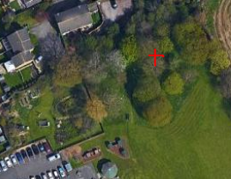
Detailed map and grid reference
What3Words:
///enhancement.action.sports
Grid Ref:
52.60832857108716,
-0.18290769860145173

The Forest School Leaders and other practitioners regard their duty of care when working with pupils as extremely important. For the safety and protection of all individuals – children, staff and volunteers - we ensure the following:
Everyone involved in Forest School is briefed on health and safety and risk assessment of the site.
Staff and volunteers are made aware of the previously mentioned policies. This is undertaken as part of school induction and orientation of all staff and volunteers. Staff and volunteers must undertake to adhere to the guidance contained within all these policies.
All members of staff at Eye C of E Primary School undertake Child Protection training. Any concerns are reported to the named Child Protection Officers, to ensure the school’s child protection policy can then be followed.
The Forest School Leaders and other school staff delivering sessions all have an enhanced level CRB check.
Suitable clothing and appropriate footwear must be worn at all times. During winter months’ pupils are expected to wear sturdy footwear or wellington boots, hats scarves, gloves and waterproof outerwear. Long sleeves and long bottoms to be worn at all times when in the forest to reduce risk of bites, stings or cuts.

Assessing and Reducing Risk at our Forest School
One of the reasons for introducing Forest School to Eye is a belief that children are sometimes overly and unnecessarily protected and cossetted from risks and that, ironically, this makes them less safe in the long run. At our Forest School we undertake a range of activities which contain a theoretical degree of risk. Through careful supervision, full training and good practice, we aim to ensure that accidents are avoided and that risks are reduced to manageable and acceptable levels. We have a full written risk assessment in place for:

- Site
- Weather conditions and general welfare
- Buildings and shelters
- Rope and String
- Fire
- Food
- Collecting natural materials
- Small tools
- Large tools

The Risk Assessments can be found on the school server and in the Forest School Folder stored in the Assistant Head’s Office. Written Risk Assessments are the starting point for our safe practice and procedures in Forest School. They are constantly reviewed and regularly updated in order to reflect the safest practice possible at Eye Primary.

Fire at Forest School
If a fire is lit at our Forest School, it is always supervised by a Forest School Leader. Fires will never be left unattended. Safe fire practice is always adhered to. There will always be a water bucket, fire gloves and fire blanket next to the fire.

Children are taught and reminded of the fire circle rules from their first visit to Forest School. These are:

- Stand behind the logs
- Step over and sit down on the logs
- Stand up, turn around and step over the logs
- Walk in a clockwise direction around the fire circle
- Keep the area around the fire circle free from debris
- NEVER go across the fire circle
- When near the fire, always use the respect position
- Only enter the fire circle area when invited by an adult

Cooking and Eating at Forest School
Forest School Leaders and other adults are aware of the following when cooking and eating at Forest School:

Open fire cooking is only permissible in the designated areas.
The respect position should always be used when near the fire.
Everyone should wash their hands before handling food and drink.
All food is stored in appropriate containers.
Only clean equipment is used.
Any dietary requirements are noted and catered for.
Food will be cooked correctly.
All equipment and waste is cleared away.

Tools
The safety of all participants is of paramount importance. Participants ensure that tools are used safely by adopting the following:

Tools are stored correctly in school and checked after each session.
Rules are set out clearly at the beginning of the tool use session.
Leaders ensure that tool talks are given before any tools are used.
Children are supervised at all times whilst using tools of any description.
Inappropriate use of tools will not be tolerated and will result in immediate withdrawal from the task.

Dealing with strangers, members of the public and dogs
Eye Primary School incorporates the Forest School site. It is surrounded by a perimeter fence, keypads or padlock on entry gates and is secure by design. However, there is always the possibility of these measures being breached. The following procedures will be adopted:

Children will be informed to never approach any person or animal (living or dead) within the forest or school grounds.
Staff will look for dog/animal owner and ask for its removal. If the dog is stray, the situation will be risk assessed and it may be determined by staff that children should be taken indoors until the dog is under control.
Children will be told to inform a member of staff who will challenge any stranger on the site.

First Aid
Level 3 Forest School Leaders are qualified in first aid and the majority of Teaching Assistants are first aid trained. There will always be a minimum of 1 first aid trained member of staff. A First Aid Kit is always available on the Forest School site. It is the Class teacher’ responsibility to ensure that the class’ First Aid Kit is brought onto the site at the commencement of the session and returned to school after each session. The staff will follow the School’s First Aid procedures.

Emergency Procedures
It is vital that emergency procedures are adhered to. These are in place to safeguard pupils and adults alike. If a serious incident takes place, it will be essential to carry out an investigation promptly.

Should a serious incident or accident occur, the Forest School Leader will ensure the safety of other participants by adopting the ‘1, 2, 3 - Come to me’ call. Participants will be made aware of this procedure for calling everyone together in initial sessions of Forest School.

In cases of emergency the Forest School Leader or other trained adult will administer first aid to the casualty. They will inform the school office who will alert parents and/or emergency services if necessary. They will inform the head teacher if the incident requires further medical treatment. If any other services are required (Fire, Ambulance etc) school procedures and report requirements will be followed and adhered to.

Roles and Responsibilities
The Forest School Leaders hold a fully recognised Level 3 Practitioners qualification. Forest School Leaders have the overall responsibility for:

Safety and risk assessment
Planning of sessions, evaluation and feedback
Liaising with school staff and governors
Supervision of tool use
Supervision of fires and cooking area
Understanding the needs of children with SEND
Emergency procedures

School Staff – Teachers and Teaching assistants
With support from the Forest School Leader, teachers and teaching assistants are responsible for:

- Observing and assessing children’s progress
- Evidencing and recording on Tapestry
- Modelling good practice
- Brining and returning the First Aid box
- Administering first aid (TA)
- Supporting and talking to pupils to extend their learning as appropriate
- Additional support when Forest School leader is supervising tools or fire activities

Volunteers and trainees
With support from the Forest School Leaders volunteers and trainees are responsible for:

Modelling good practice
Supporting and talking to pupils to extend their learning as appropriate
Additional support when Forest School leader is supervising tools or fire activities
Additional delegated jobs

Insurance

Insurance for activities within Forest School are included within the school’s insurance policy.

Equal Opportunities
In the first instance please refer to the school Equality Policy.
All people involved in Forest School sessions will be treated with respect and equality. Our priority is to ensure that children and adults have access to a safe and secure environment. We believe that any contributions made by staff, volunteers and participants in our sessions will be listened to and appreciated.

Evaluation Procedure
The Forest School Leader has developed a long term progressive plan. They undertake to reflect and evaluate each session after its completion. At the end of each term the leaders meet to reflect on current activities, take into account feedback from all participants and then use this to inform future planning.

Policy Written: October 2021

To be reviewed: October 2021
Reviewed : October 2021
October 2022
October 2023
September 2024

Eye C of E Primary School Sustainability Plan

It is important to bear in mind the ecological impact of running a Forest School in the woodland at Eye and with that in mind consideration will be given to the following:

Any fire will be contained within the fire pit which is situated within the centre of the fire circle.
There will be a maximum of one fire per week to reduce the impact of the smoke disturbing any nesting birds in the upper canopy of the forest
The above actions will limit the amount of dead wood that is burnt as it is important for the soil layer of the forest
Children will be educated not to pick up anything still growing

At Eye Primary, the area that has been set aside for Forest School had become over run with brambles and rubbish such as wires, crisp packets and bottles. The Forest School site has been cleared of debris and ground covering brambles, giving the area’s trees and bushes the opportunity to recover and develop as a natural woodland area.

Woodland Management Plan

Year 1

- Coppicing and removal of undergrowth approx. 1/2 of the site
- Use sticks for shelter/den building
- Staff and volunteers remove rubbish, deadwood and brambles
- Clear a fire pit and fire circle
- Clean shelter over the fire pit
- Tidy storage shelter for tools and resources
- Allow an area or grass to grow to create wild meadow area

Year 2
- More removal of undergrowth running through the middle of the site
- Allow some previously chopped down young trees to grow.
- Remove some bramble from the boundary (1/3) ensuring an area of nettles and brambles is left to support wildlife.
- Cut back cow parsley around fire circle.
- Tidy cooking area
- Tidy storage shelter for shelter building resources
- Re-erect bug insect house/area from natural materials
- Enhance wild meadow area

Year 3
- Clear brambles/ nettles as last year
- Plan for new area to allow for nettle and bramble growth.
- Look into planting new trees/plants to support a wider range of wild life.
- At the end of the year plan for new fire pit area and move all needed equipment/ resources.

